Roseburg DMV Project
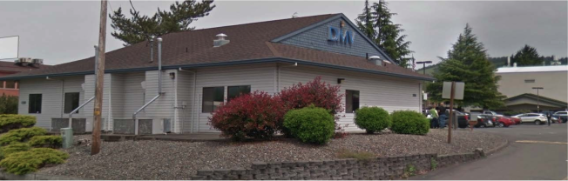
1331 NE Cedar St
Roseburg, OR 97470

Oregon Department of Transportation – Facilities Service Branch
Project Manager: Eric Spond
Suite B240, 200 Hawthorne Ave SE
Salem, OR 97301
Phone: (503) 986-2810

Table of Contents
Roseburg DMV Project 1
Overview 2
Camera Parts list: 2
Other Materials: 2
Camera Locations 3
Camera 1 3
Camera 2 6
Camera 3 8
Camera 4 10
Camera 5 12
Camera 6 14
Server Room 15

Overview
The Roseburg DMV project includes: 6 cameras, 1 decoder, 2 monitors, 1 UPS, and a small PC.

Camera Parts list:
- QTY 3: PNM-9030V
- QTY 1: PND-9080R
- QTY 1: PNF-9010R
- QTY 1: PNV-9080R
- QTY 2: SBP-276HM
- QTY 2: SBP-300WM1
- QTY 1: SPD-150

Other Materials:
- QTY 1: Peerless Ceiling Mount
- QTY 1: 6’ HDMI Cable
- QTY 1: 10’ HDMI Cable
- QTY 2: 32” Samsung TVs
- QTY 1: Intel NUC PC
- QTY 1: Keyboard / Mouse Combo
- QTY 1: UPS
- QTY 3: Under Surveillance Signs

Camera Locations

Camera 1
Camera Model: PNM-9030V
Required Accessories:
QTY 1: SBP-276HM
QTY 1: SBP-300WM1
Mounting Location: The camera to be installed on the east side of the building. It should be mounted midway between the posts on the overhang, high enough to keep it somewhat out of reach while low enough to capture an adequate image of the parking/staging area. Conduit is required to protect the cabling. Painting of the conduit is NOT required.
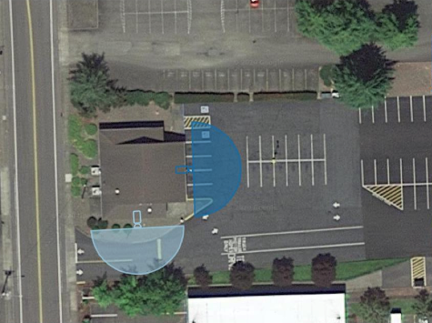
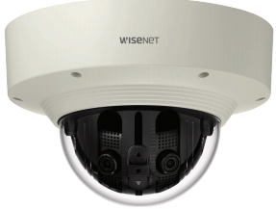
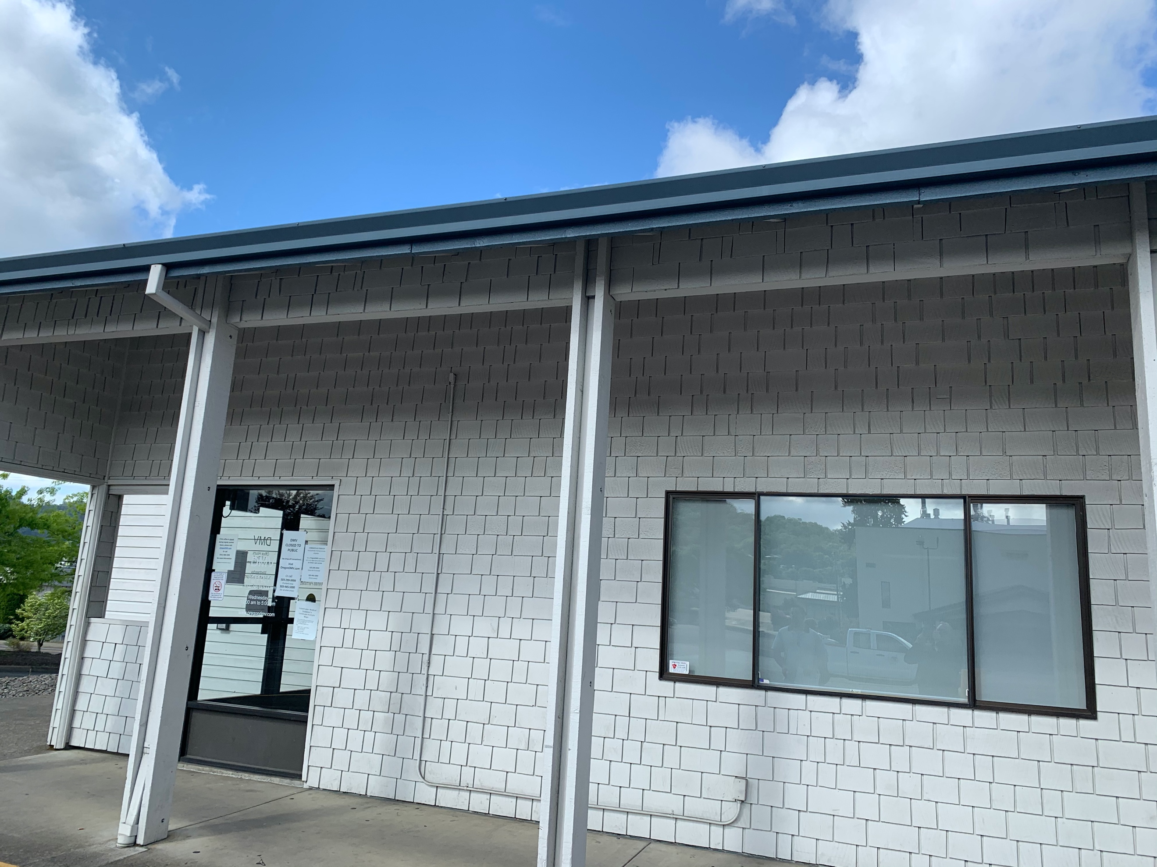
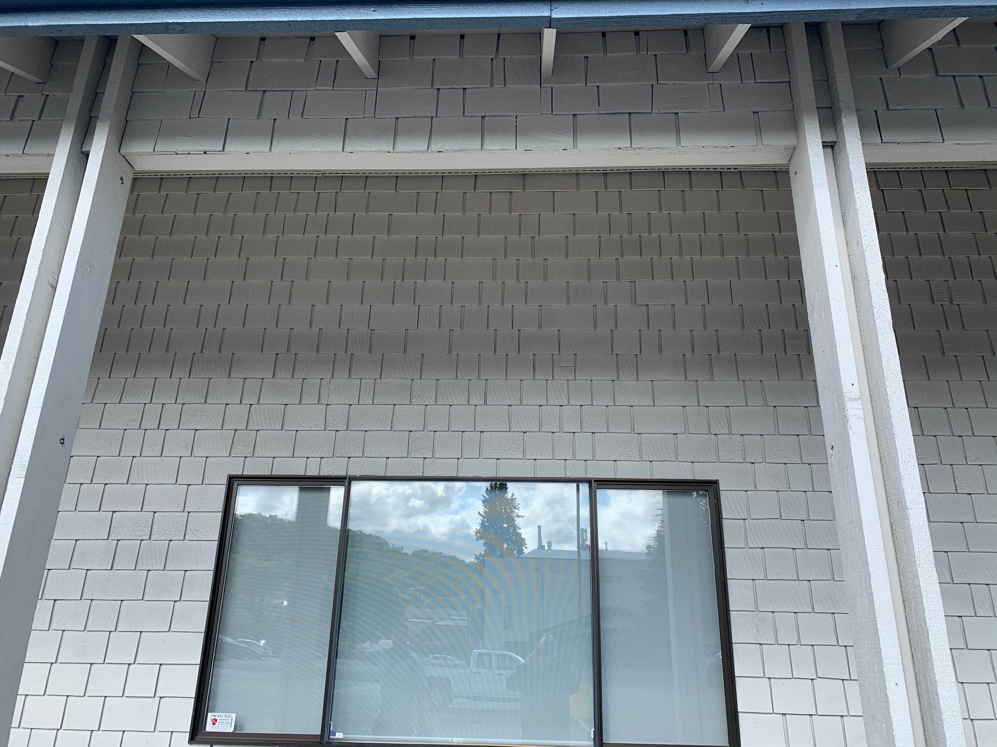
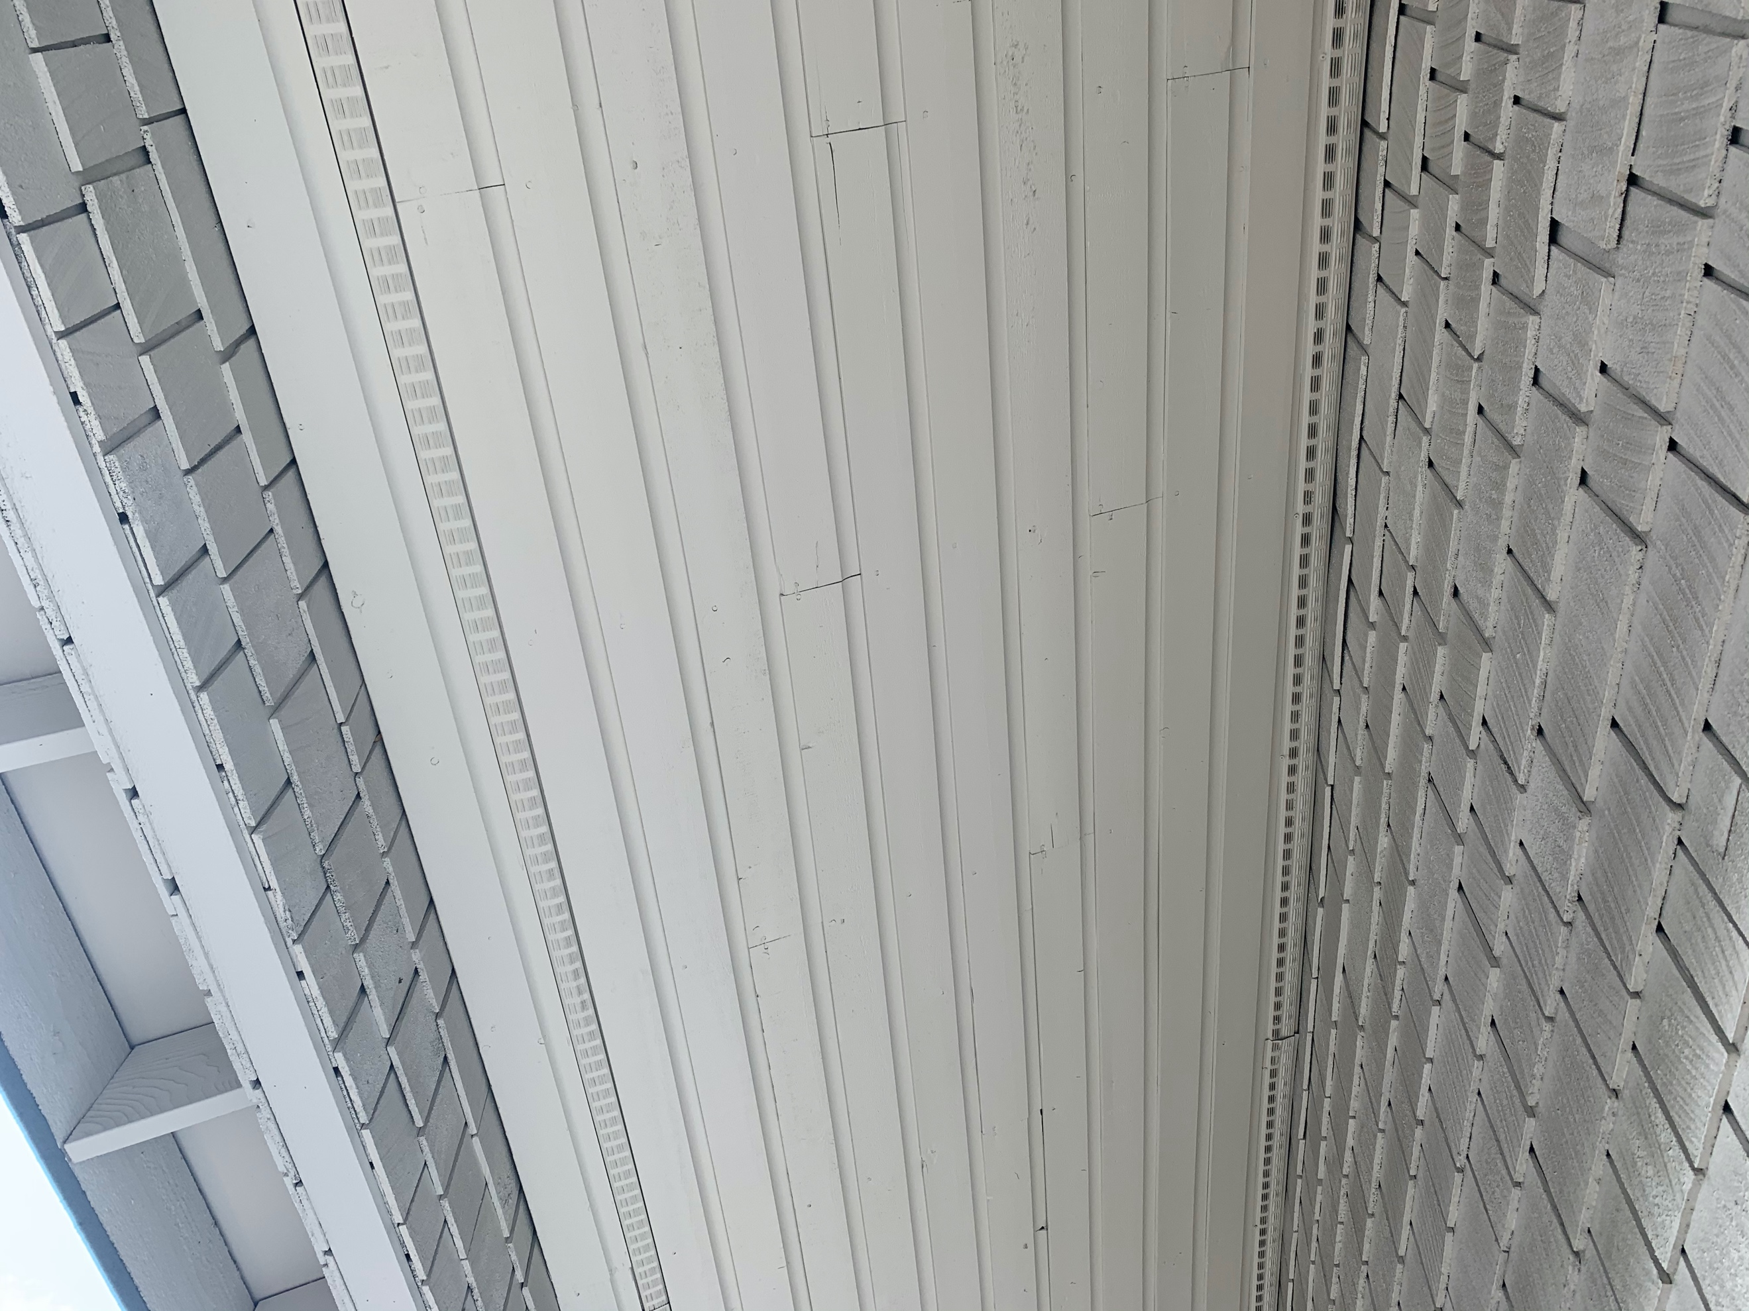

Camera 2
Camera Model: PNM-9030V
Required Accessories:
QTY 1: SBP-276HM
QTY 1: SBP-300WM1
Mounting Location: The camera to be installed on the south side of the building. It should be mounted to roughly 6’ from the edge of the window and about 8” below the soffit. Conduit is required if cabling comes from below.
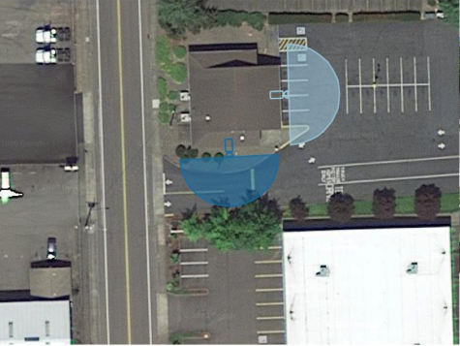
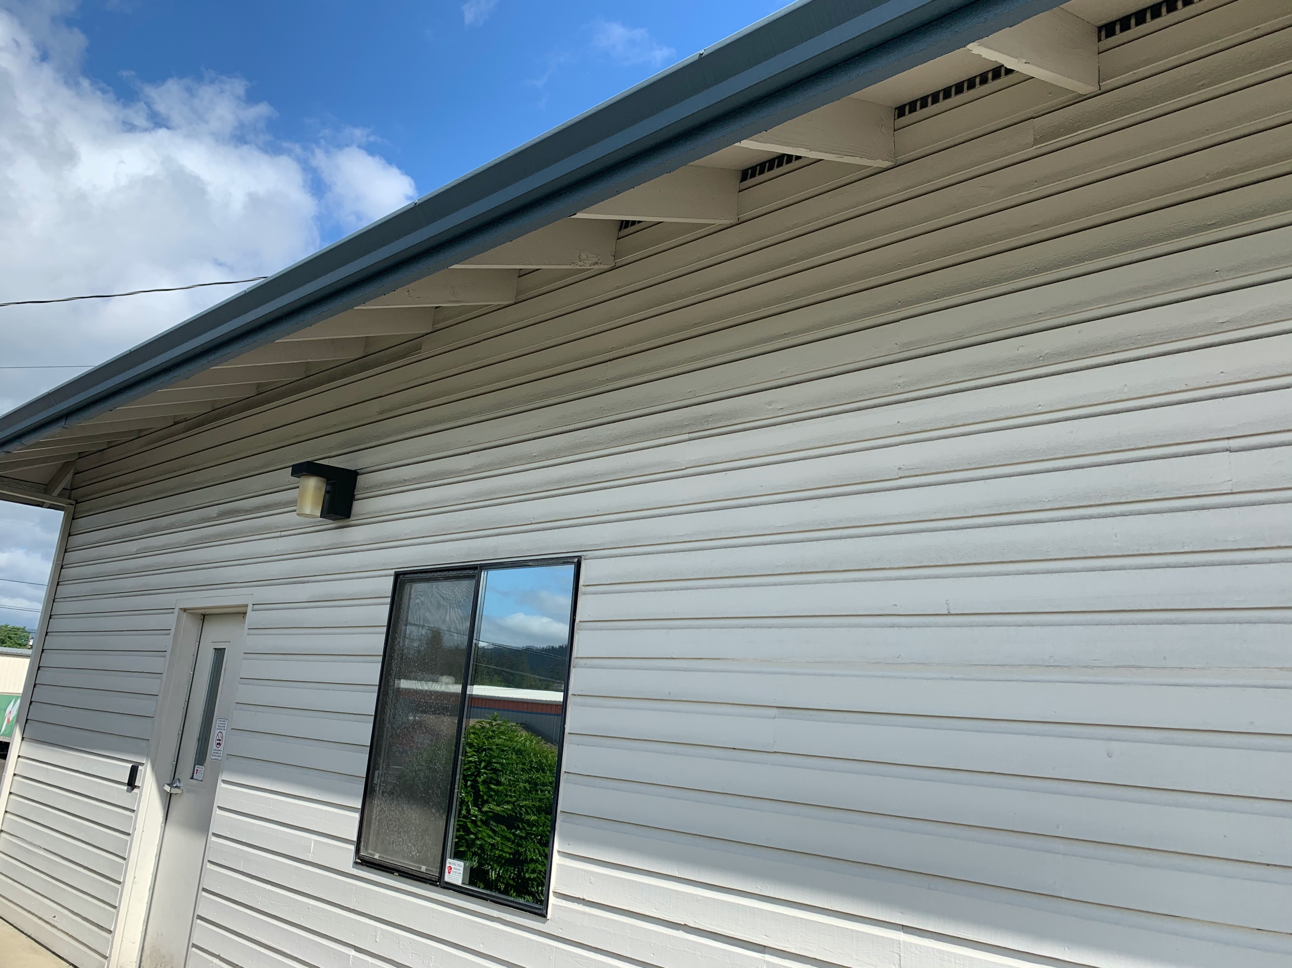
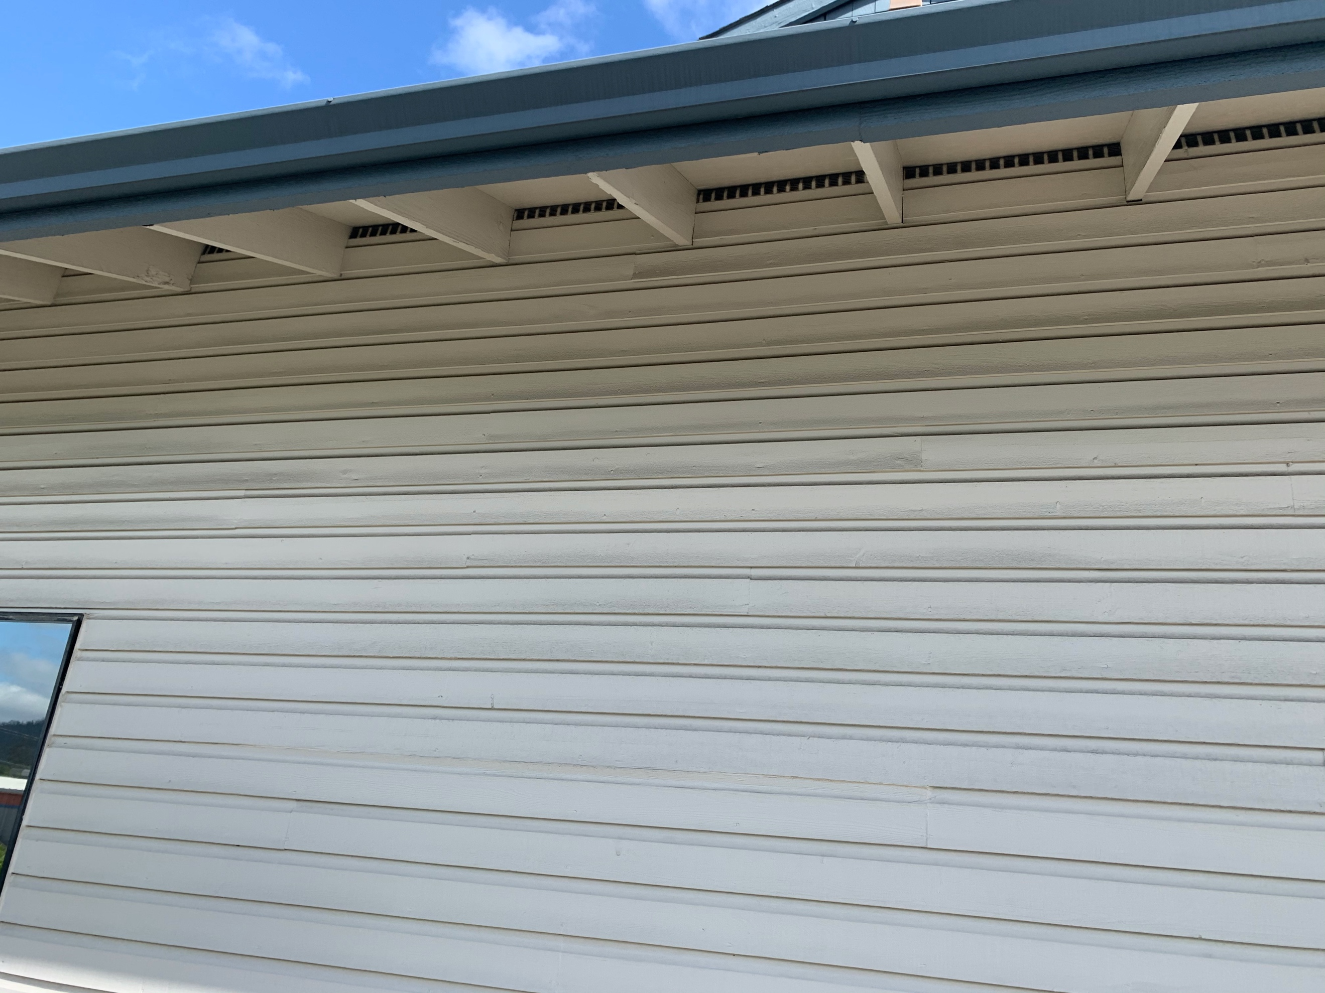

Camera 3
Camera Model: PND-9080R
Required Accessories:
QTY 1: 32” Samsung Monitor
QTY 1: Peerless Ceiling Bracket
QTY 1: 10’ HDMI Cable
QTY 1: SPD-150 (Decoder)
QTY 1: Electrical Outlet
Mounting Location: The camera needs to be mounted to a roughly in line with the interior doorjamb (6’ from eastern wall) at a distance equal to the existing welcome sign. The TV and subsequent Decoder need to be installed at the location currently occupied by the welcome sign. The welcome sign should be moved so it in between the new camera and the TV. The Decoder should be attached to the ceiling bracket above the tile, so it is out of view. Route the HDMI cable from the Decoder to the HDMI 1 port on the TV.
Both the camera and the Decoder will require a CAT6 cable run.
The TV will require power scabbed off of an existing outlet.
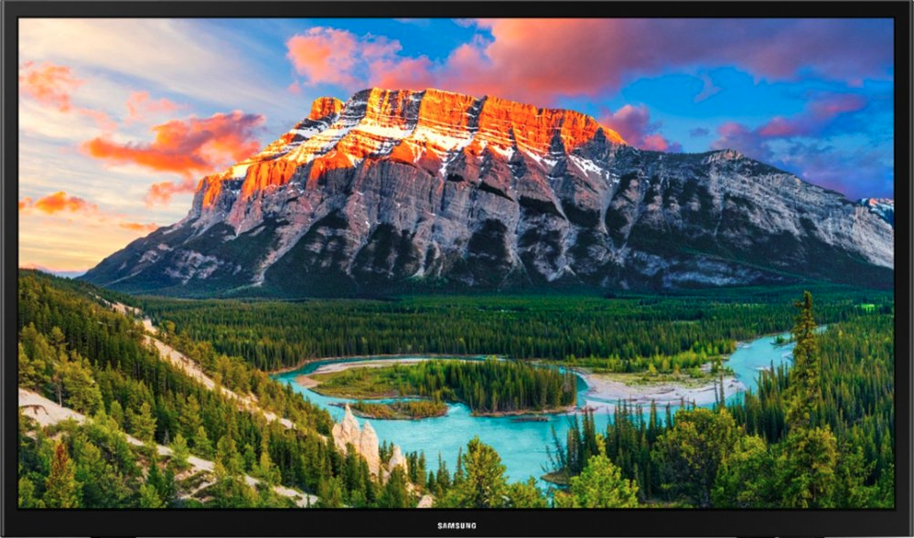

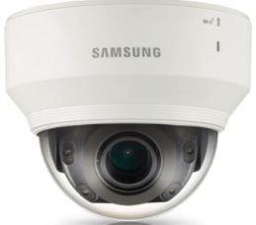
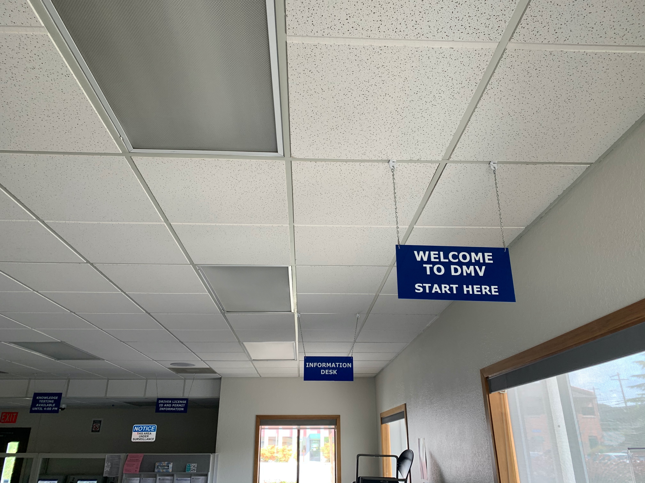
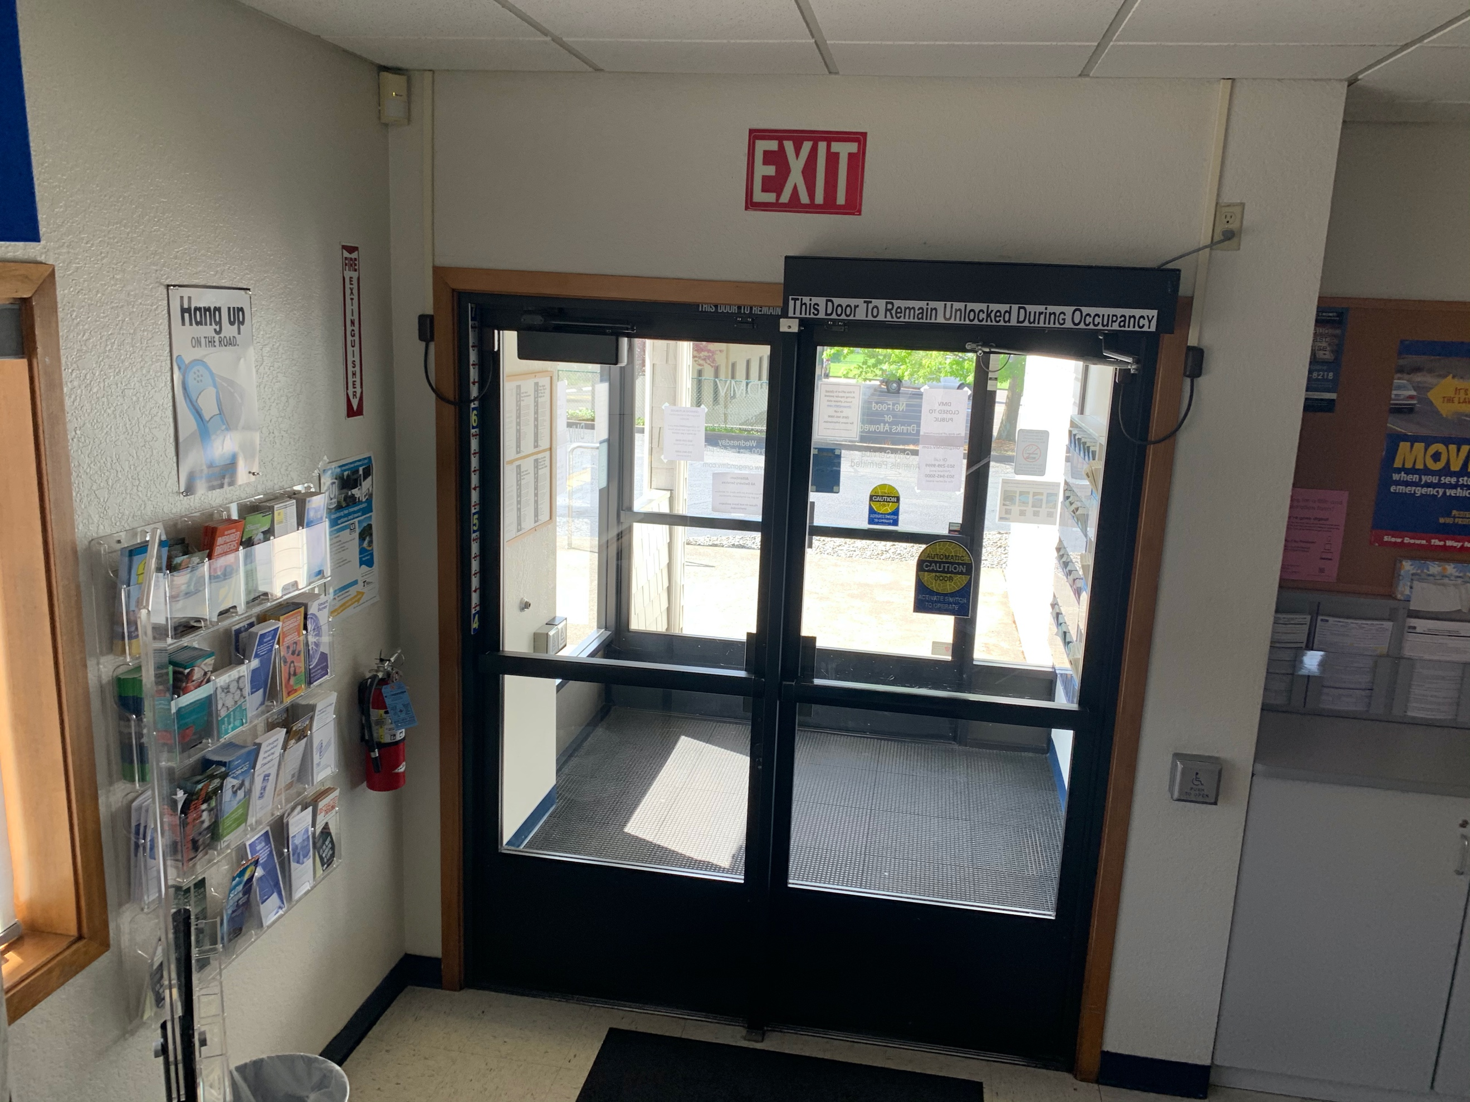
Camera view
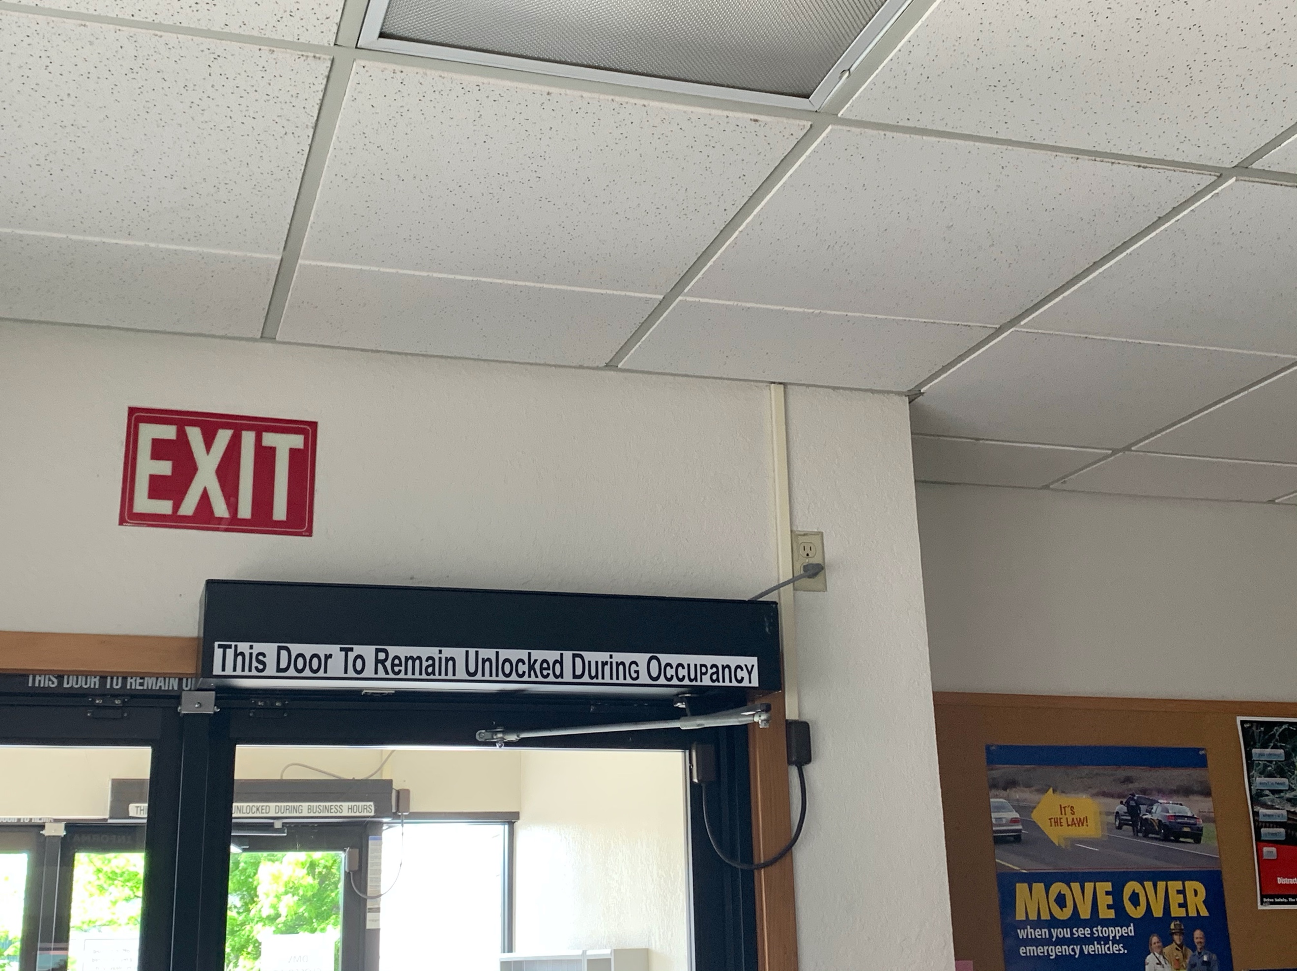
Suggested scab outlet

Camera 4
Camera Model: PNM-9030V
Required Accessories:
None
Mounting Location: The camera should be installed in between the clock and the top row of license plates. Due to the weight of the camera, we may need a mounting plate above the tile. Wall mounting is NOT an option. The camera weights roughly 7 lbs.
The required view is of the customer side of the counter space. The VMS implementation will handle the required masking of the image.
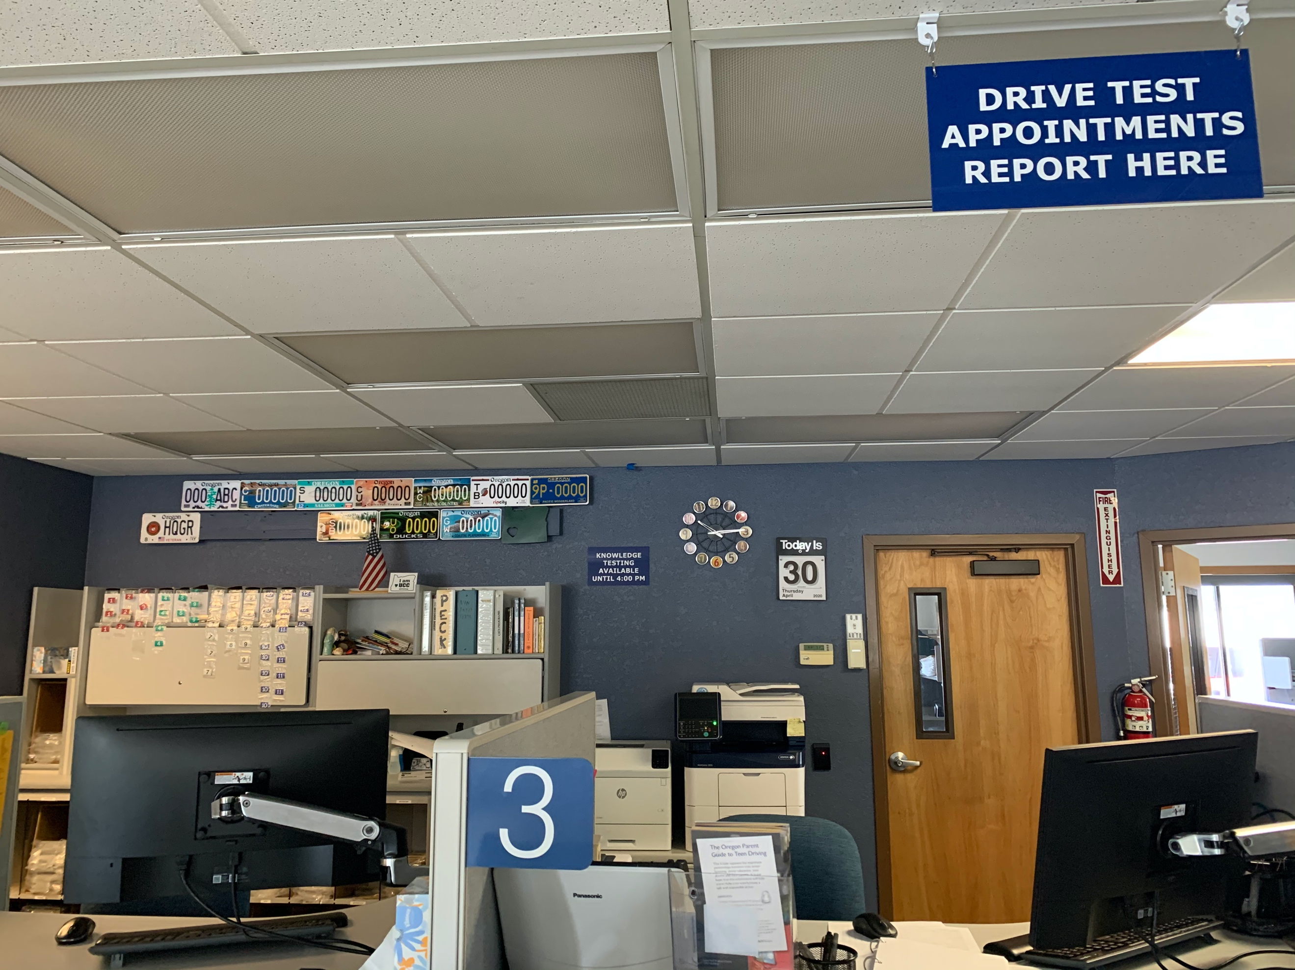
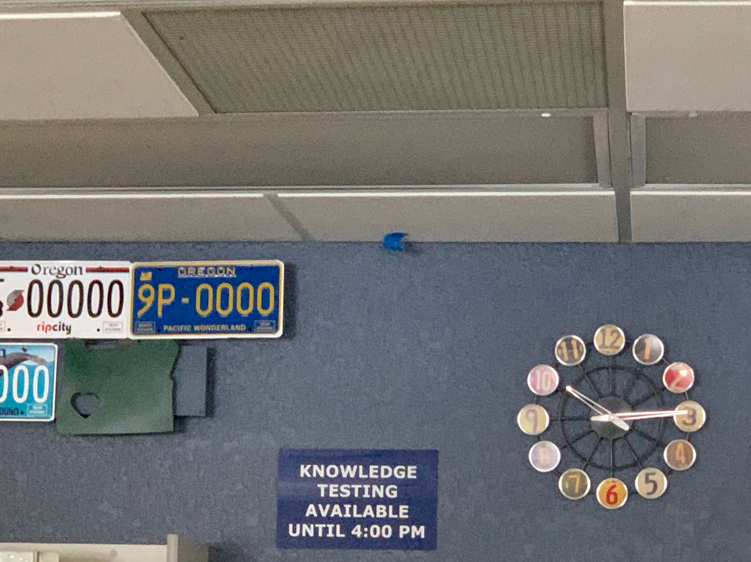

Camera 5
Camera Model: PNF-9010R
Required Accessories:
QTY 1: 32” Samsung Monitor
QTY 1: Intel NUC PC
QTY 1: 6 HDMI Cable
QTY 1: Keyboard / Mouse Combo
Mounting Location: The camera should be installed to the center of the room (on the door side of the speaker). This is a 360° camera and the intention is to cover the comings and goings of this room and monitoring the safe located in the corner.
This room will also house the viewing PC.
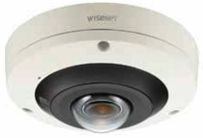
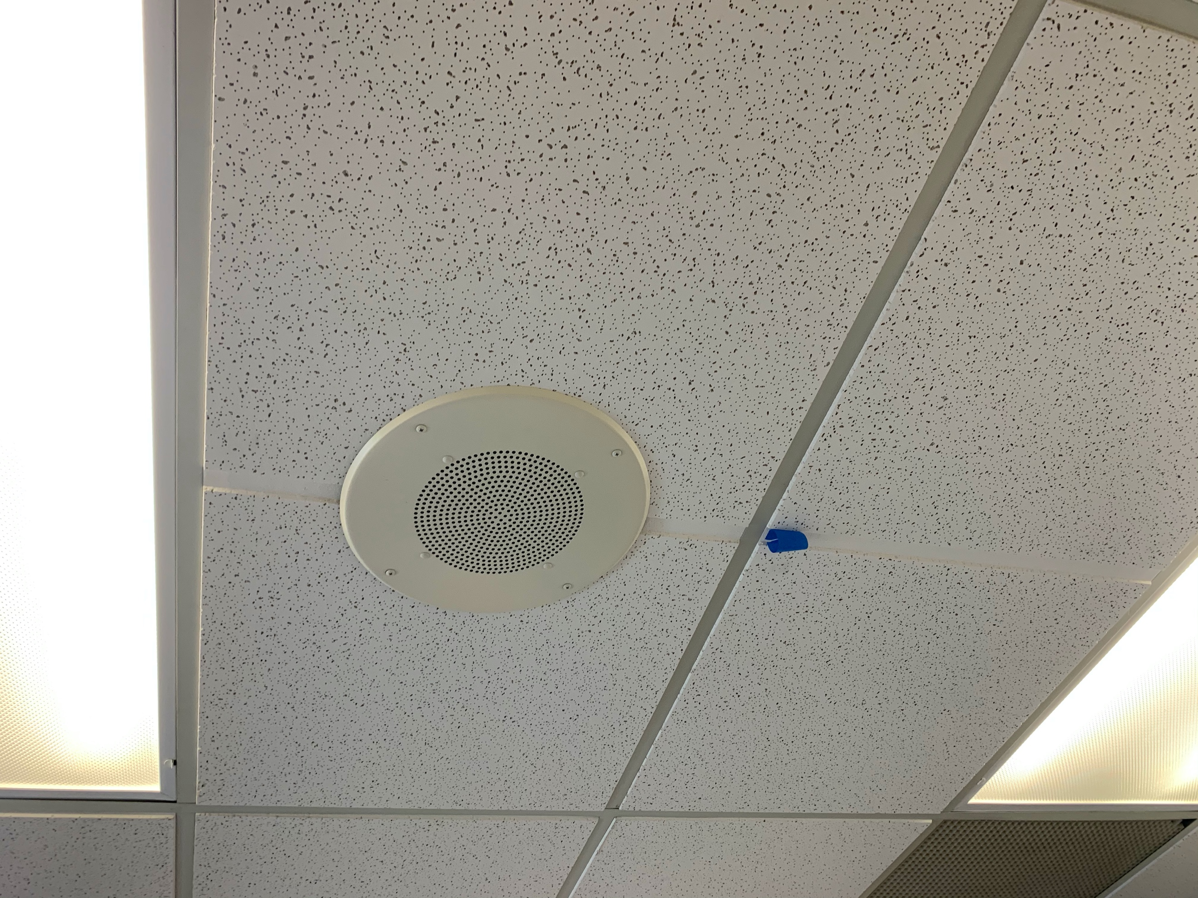
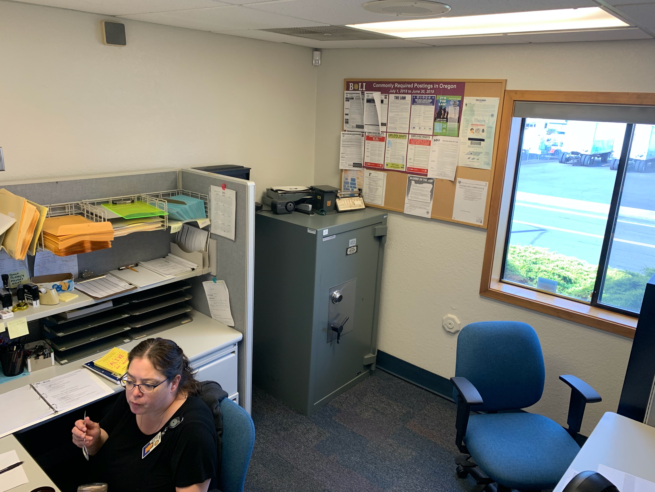
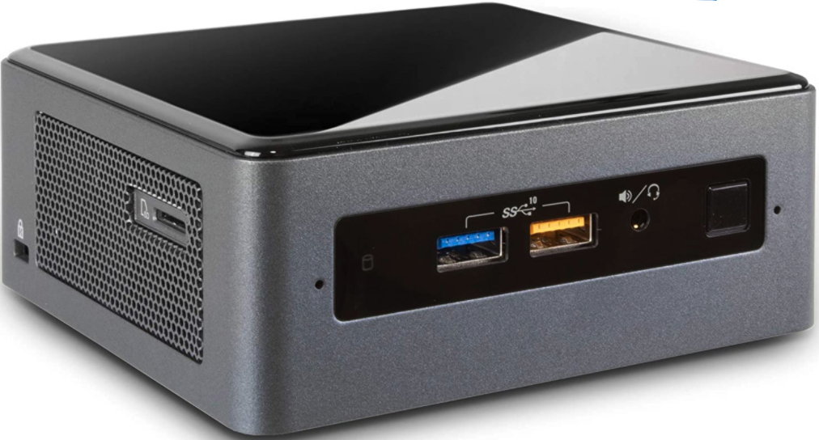
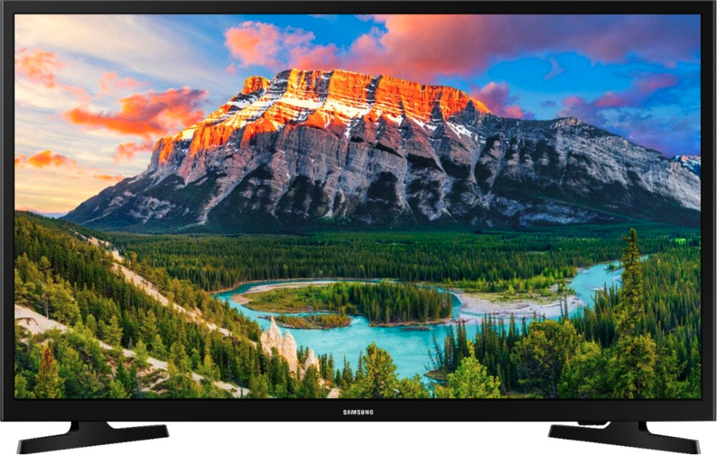
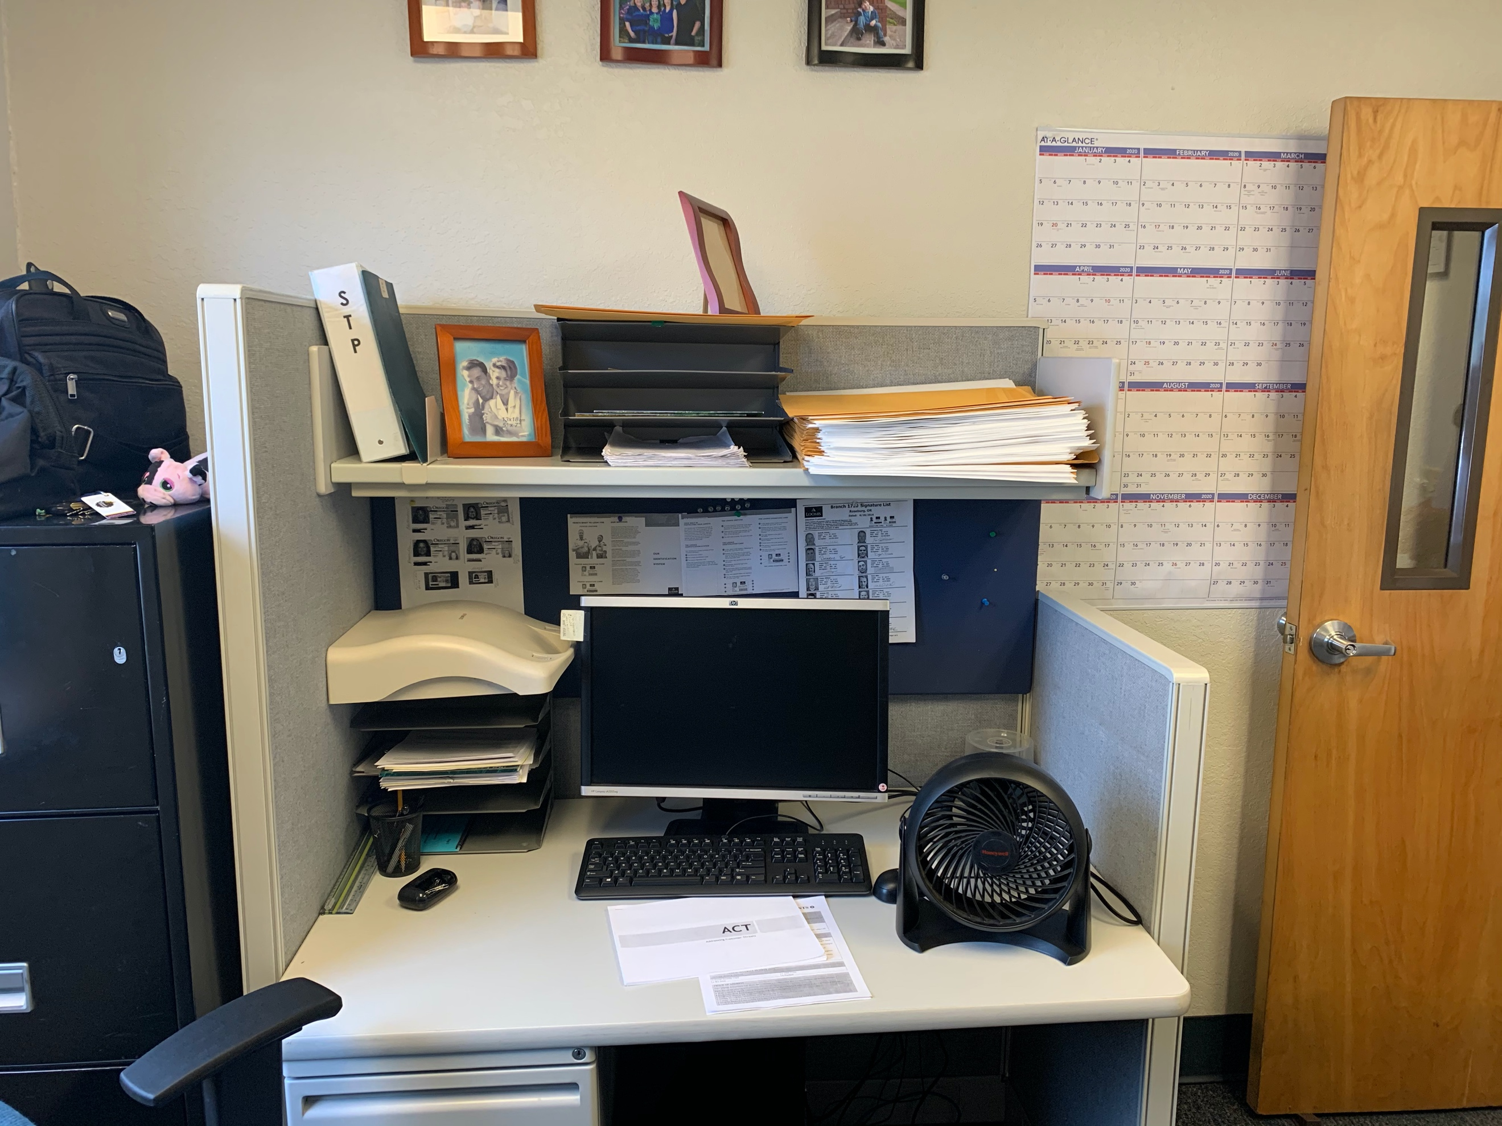

Camera 6
Camera Model: PNF-9010R
Required Accessories:
None
Mounting Location: The camera should be installed roughly in between the two existing cameras. This project does NOT include demolition, so the existing cameras, and their subsequent cabling, need to stay in place. This is a 360° camera and the intention is to cover the testing area.
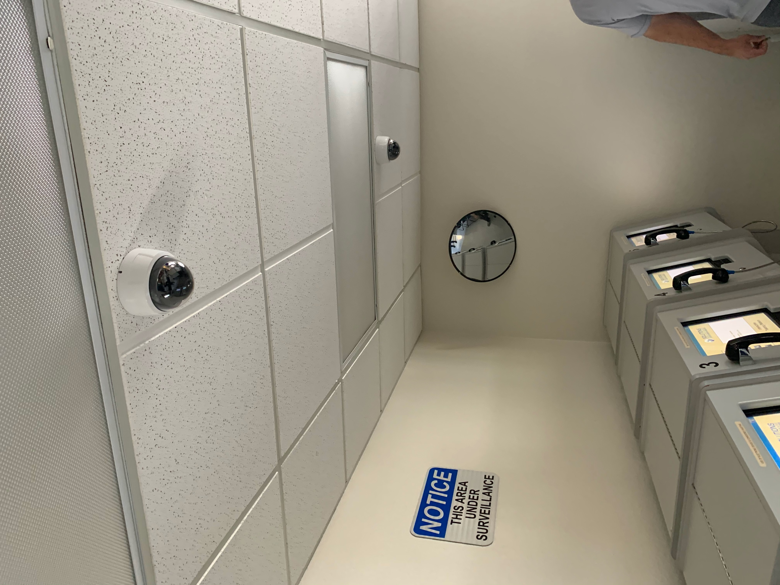

Server Room
Camera Model: None
Required Accessories:
QTY 1: UPS
QTY 1: CAT6 Patch Panel
QTY 1: Electrical Outlet
Mounting Location: The UPS is to be installed at the bottom of the existing 2-post rack, and the patch panel should be installed far enough above it to allow room for their VMS server (to be installed by another contractor). This location will require an electrical outlet to be installed near the floor. This outlet can be scabbed off of one of the exiting outlets on the same wall.
All cabling needs to be clean and dressed along the inside of one of the posts. Their IT department will be VERY critical of cable management. The existing cabling is an example of what NOT to do. A new sleeve into the attic is required.
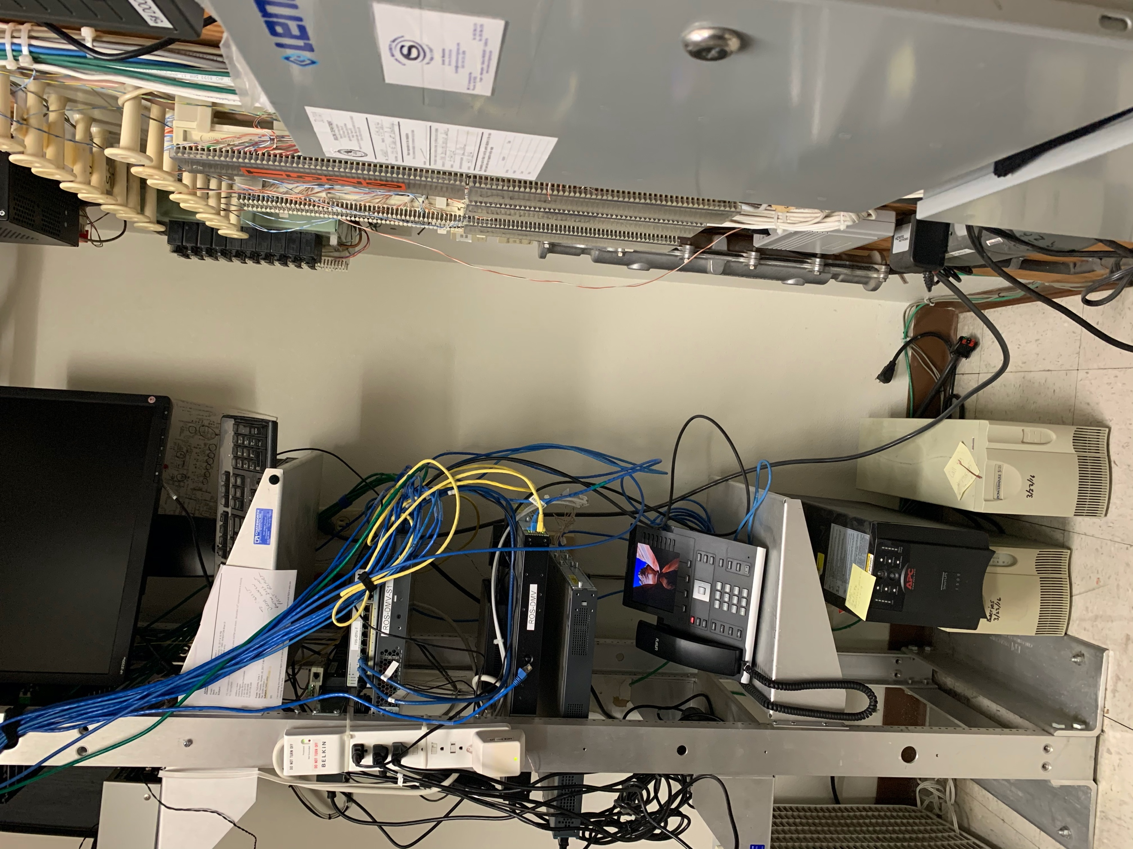
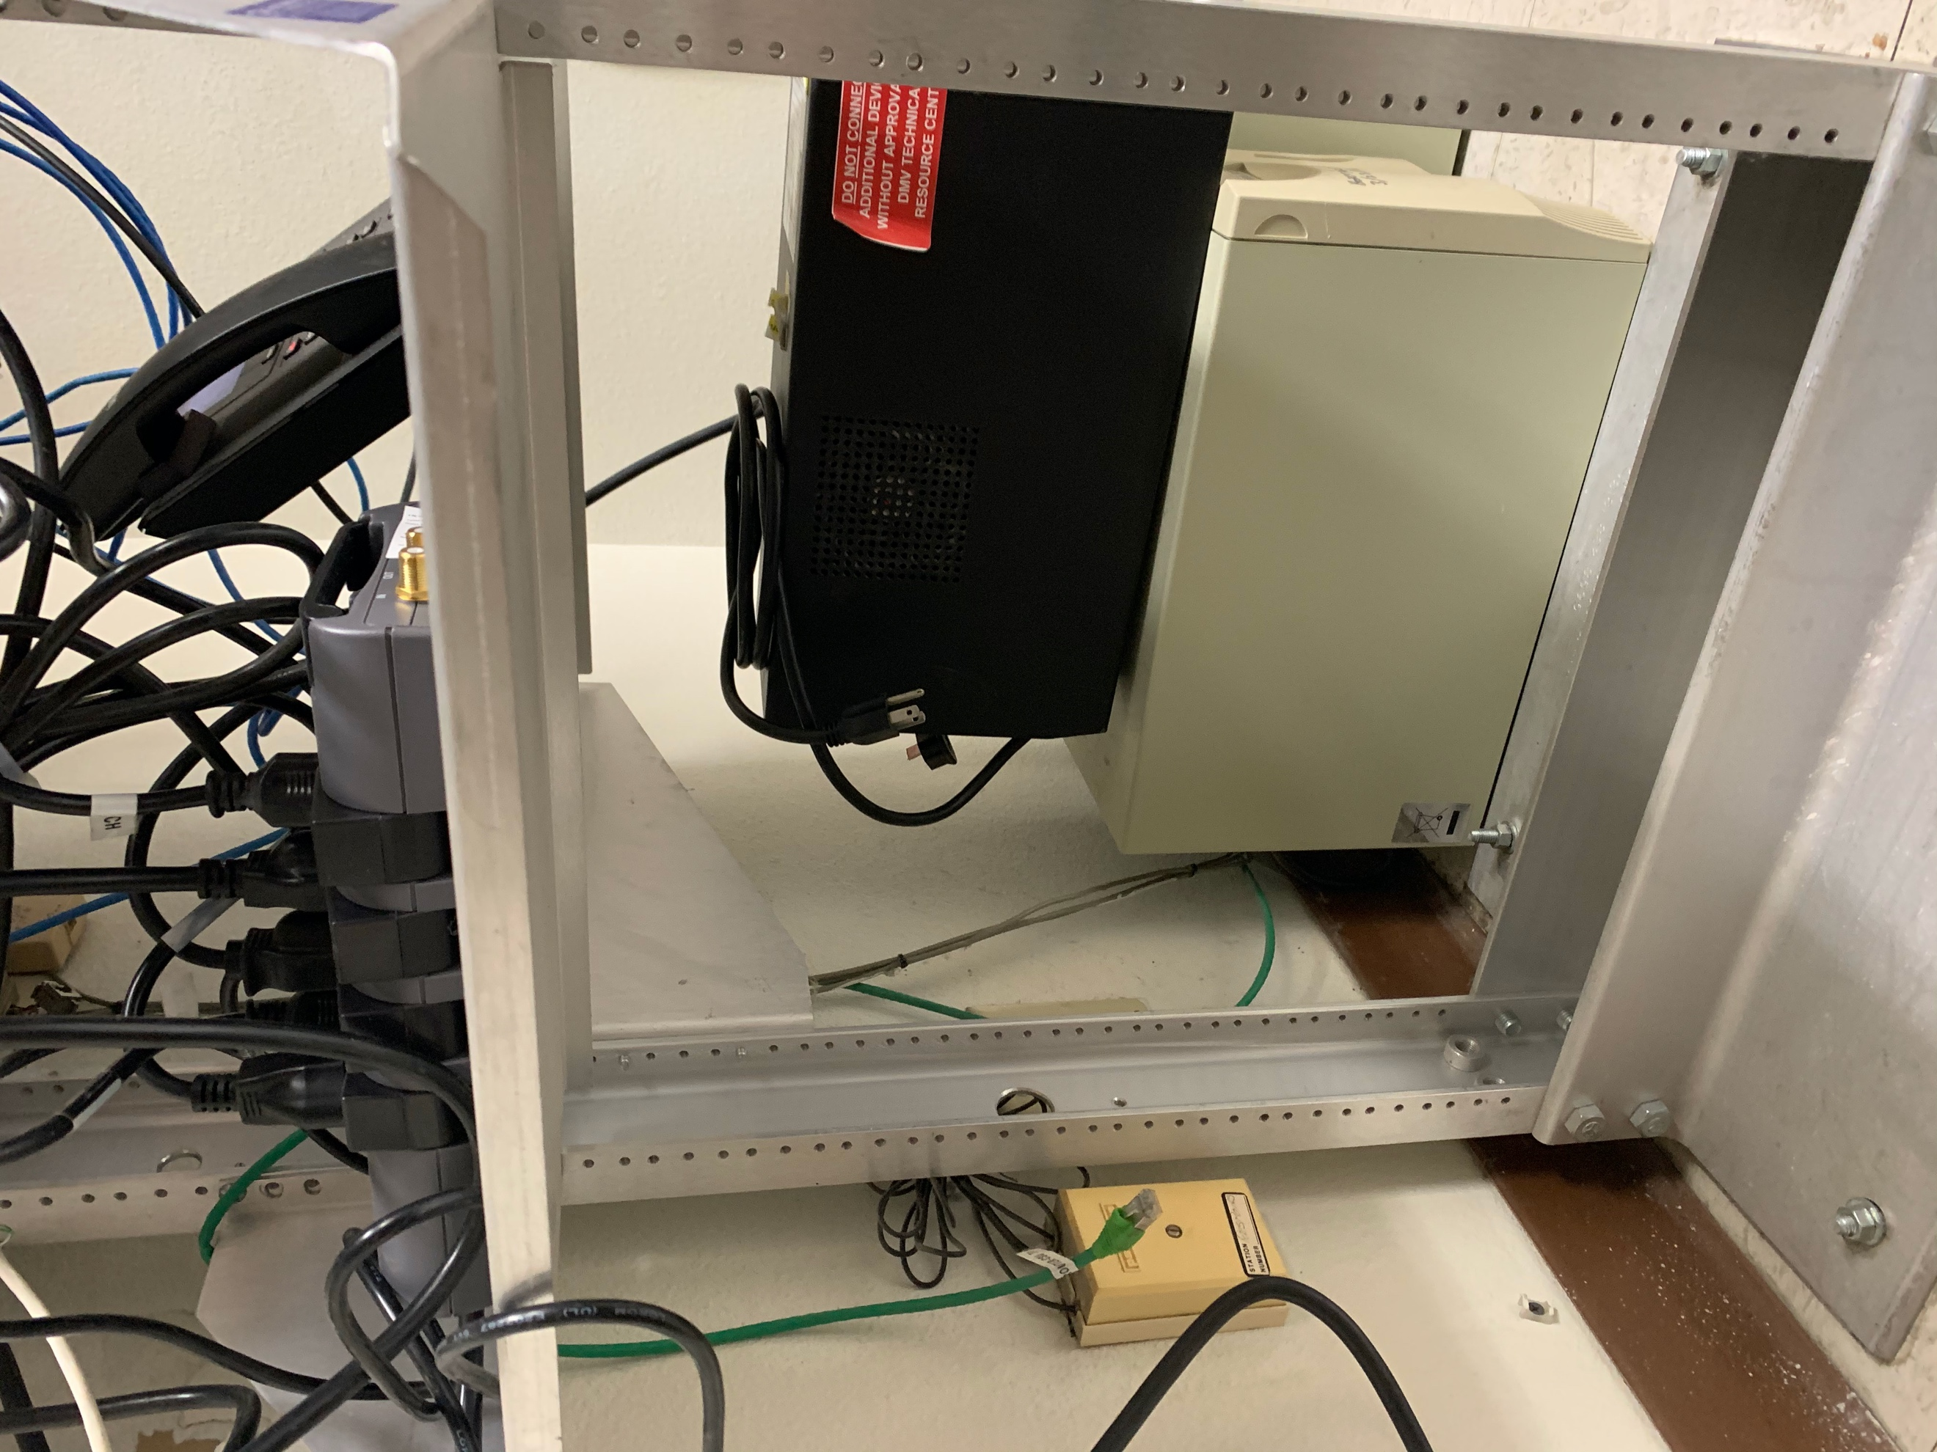
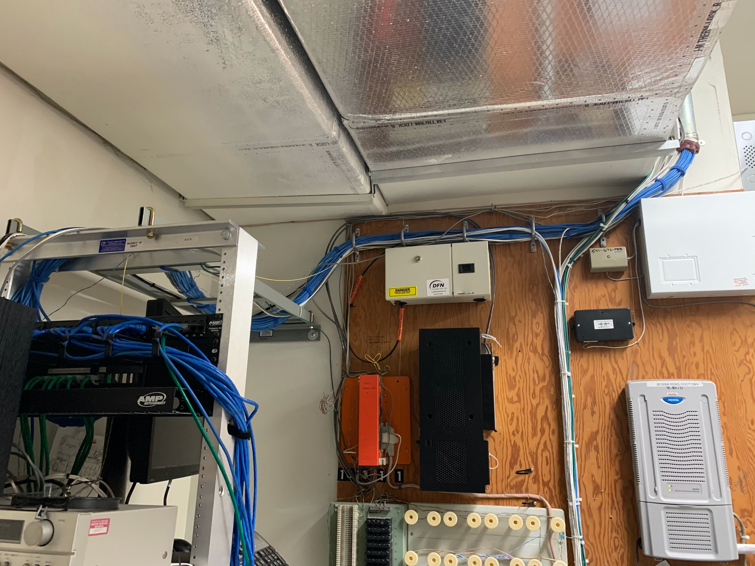
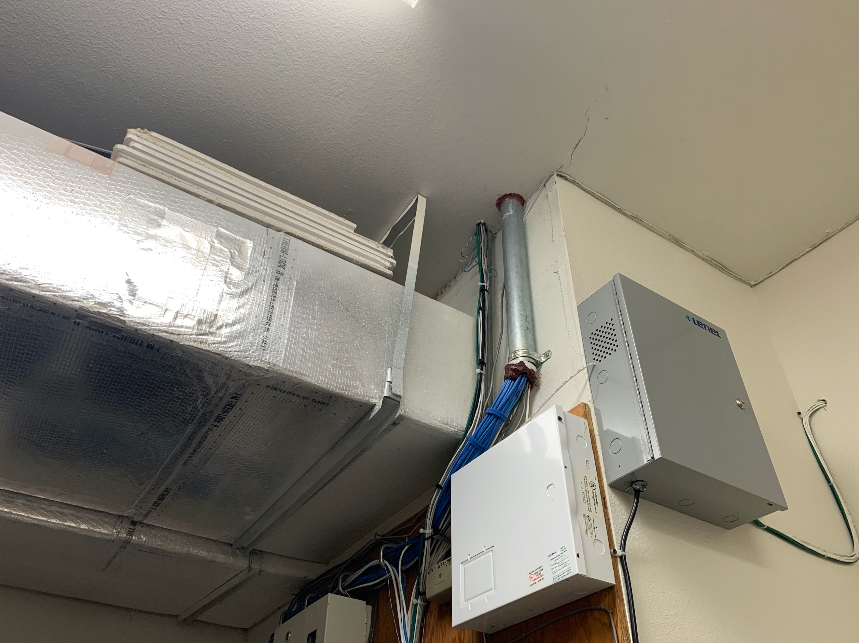
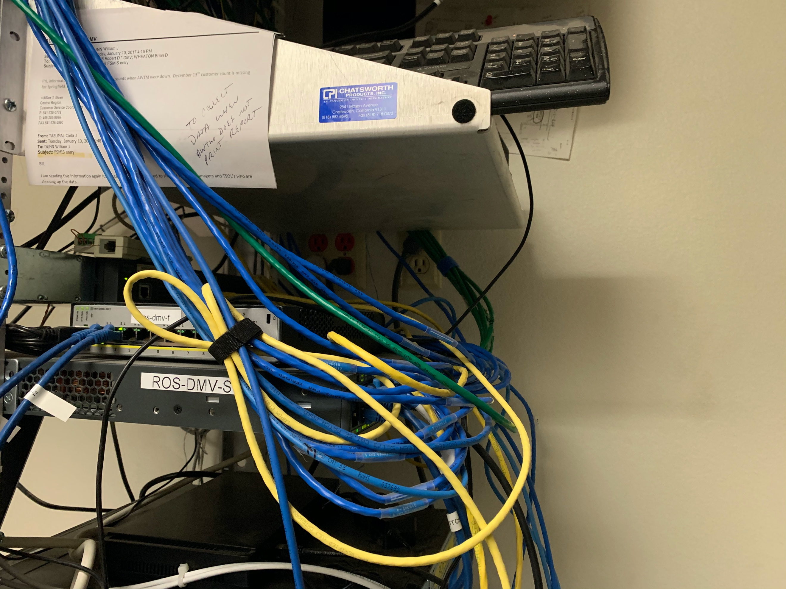

Additional server room Notes
Prior to disconnecting power, the rack needs to be powered down. The PC in the rack does not require a password to operate. This PC needs to be powered down nicely. All other equipment can be unplugged without additional procedures.
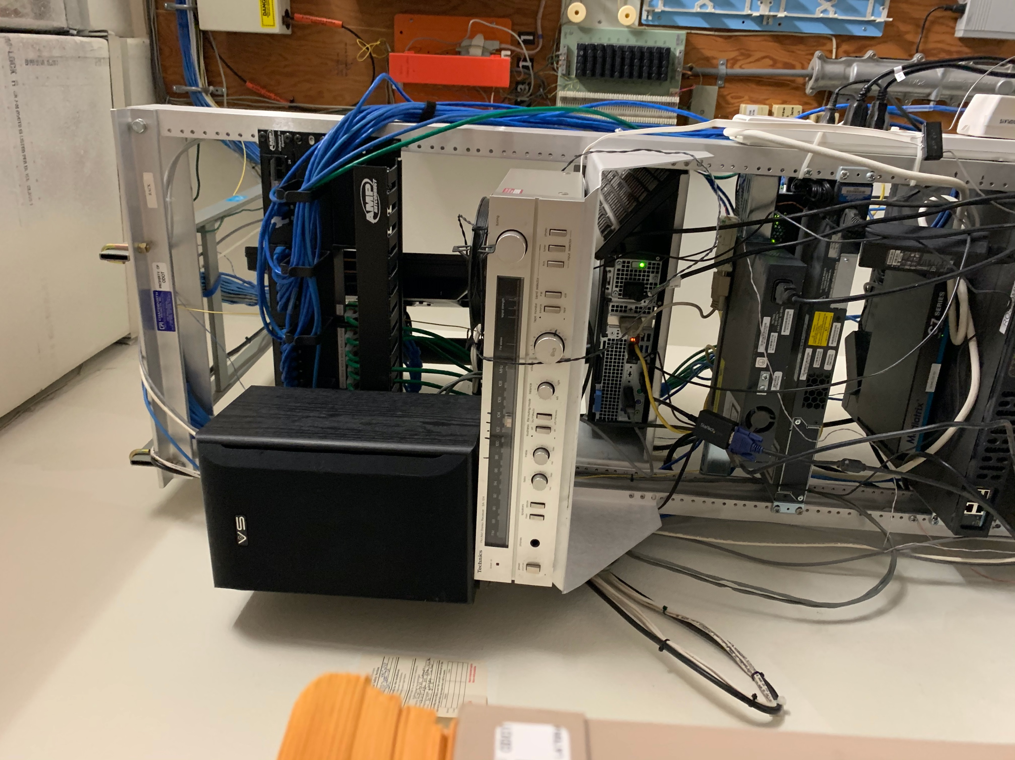
The server room can be used to store cable and equipment after hours and when not being used.

