Roseburg DMV – Solution OVerview
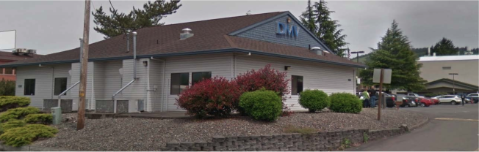
1331 NE Cedar St
Roseburg, OR 97470

Oregon Department of Transportation – Facilities Service Branch
Project Manager: Eric Spond
Suite B240, 200 Hawthorne Ave SE
Salem, OR 97301
Phone: (503) 986-2810

Table of Contents
Roseburg DMV – Solution OVerview 1
Solution Overview 3
Camera Parts list: 3
Passwords and Notes: 3
Other Materials: 3
Camera Locations 4
Camera 1: 4
Camera 2: 6
Camera 3: 8
Camera 4: 10
Camera 5: 12
Camera 6: 14
Server Room: 15

Solution Overview
The Roseburg DMV project includes: 6 cameras, 1 decoder, 2 monitors, 1 UPS, and a small PC.

Camera Parts list:
- QTY 3: PNM-9030V
- QTY 1: PND-9080R
- QTY 2: PNF-9010R
- QTY 2: SBP-276HM
- QTY 2: SBP-300WM1
- QTY 1: SPD-150

Passwords and Notes:
- Cameras and Encoder have had firmware updates installed.
- All cameras and encoder are configured to use the following credentials.
Username: admin
Password: N3wP@ssw0rd
- Intel NUC PC has been tested and verified for functionality but has no initial configuration. As a result, no Windows updates have been applied.

Other Materials:
- QTY 1: Peerless Ceiling Bracket – Model PLCM-UNL-CP
- QTY 1: 6’ HDMI Cable
- QTY 1: 10’ HDMI Cable
- QTY 2: 32” Samsung Monitors – Model UN32N5300AFXZA
- QTY 1: Intel NUC PC – Model NUC8i7BEH
- QTY 1: Logitech Wireless Keyboard / Mouse Combo – Model MK235
- QTY 1: Vertiv UPS – Model GXT5-500LVRT2UXL
- QTY 3: Under Surveillance Signs

Camera Locations

Camera 1:
Camera Model: PNM-9030V
Required Accessories:
QTY 1: SBP-276HM
QTY 1: SBP-300WM1
Mounting Location: The camera to be installed on the east side of the building. It should be mounted midway between the posts on the overhang, high enough to keep it somewhat out of reach while low enough to capture an adequate image of the parking/staging area.
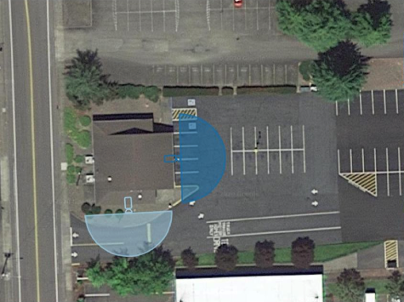
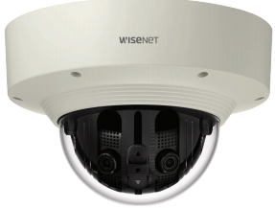
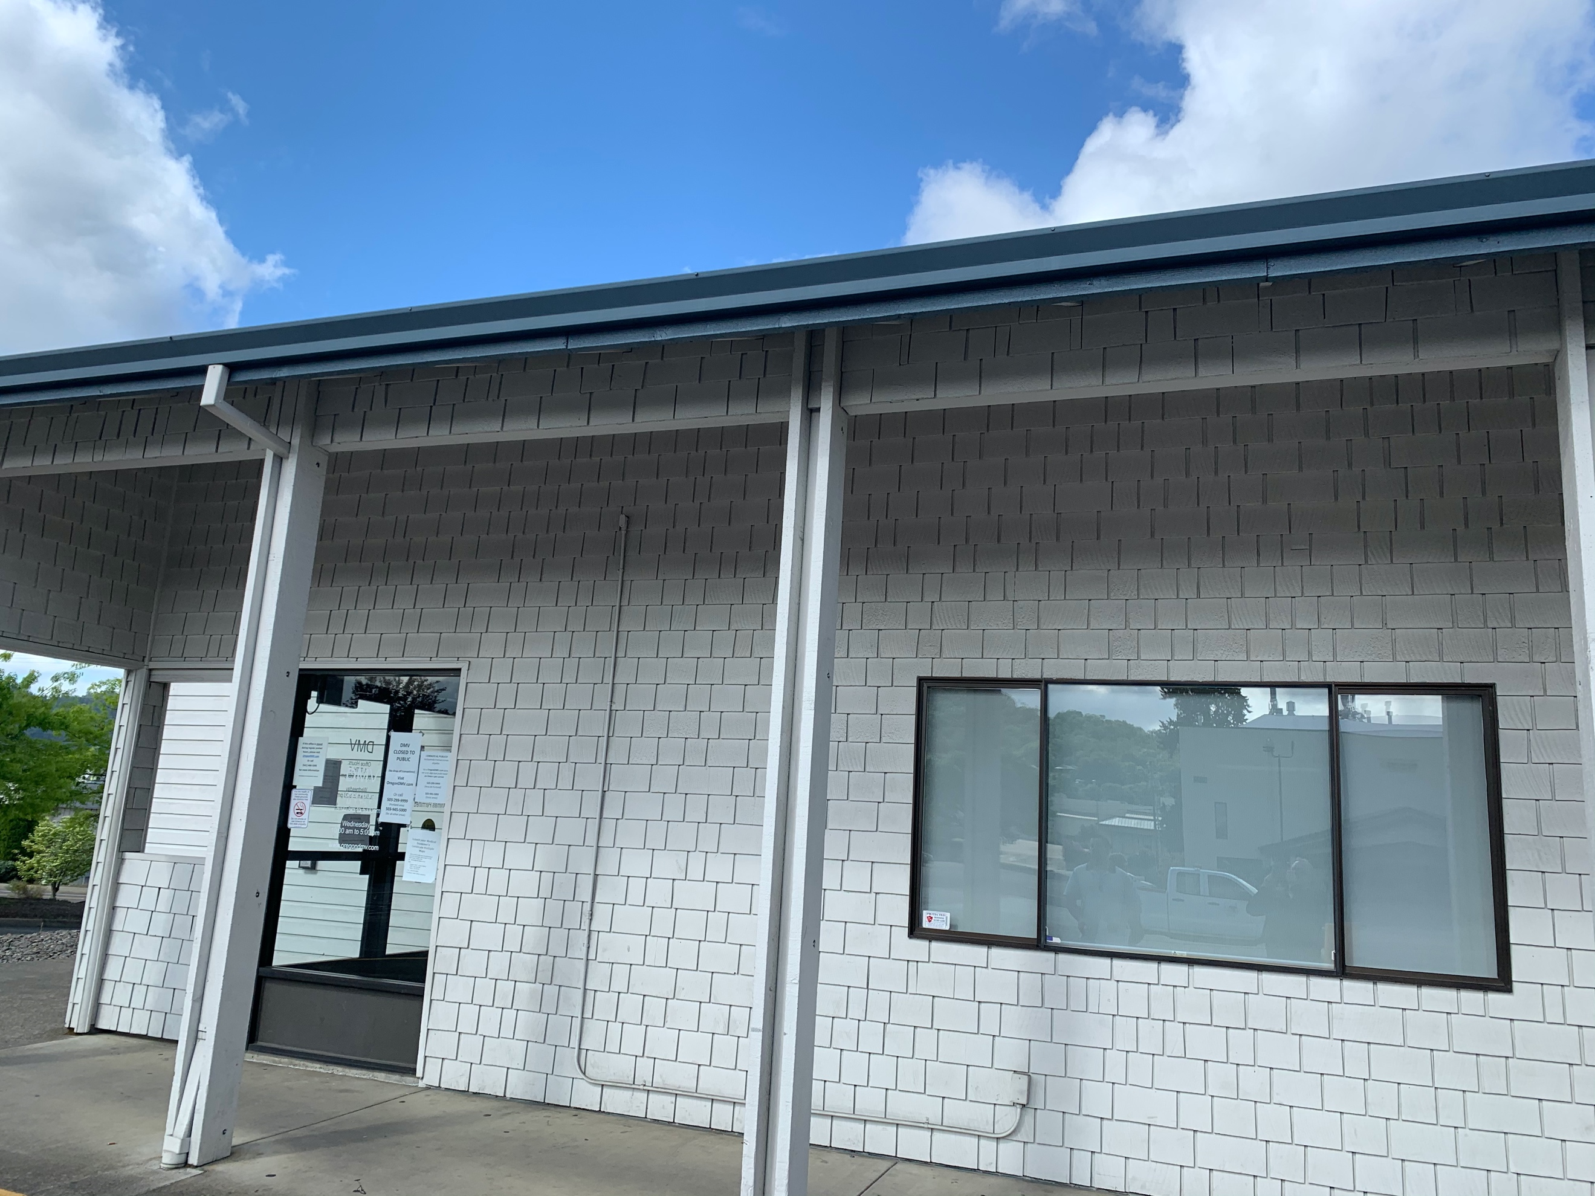
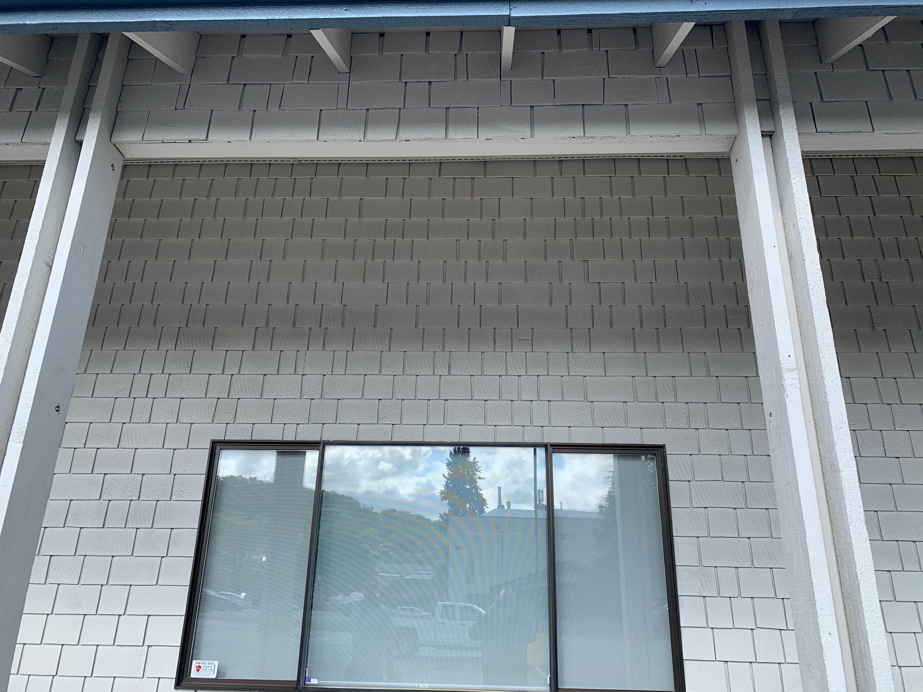

Camera 2:
Camera Model: PNM-9030V
Required Accessories:
QTY 1: SBP-276HM
QTY 1: SBP-300WM1
Mounting Location: The camera to be installed on the south side of the building. It should be mounted to roughly 6’ from the edge of the window and about 8” below the soffit.
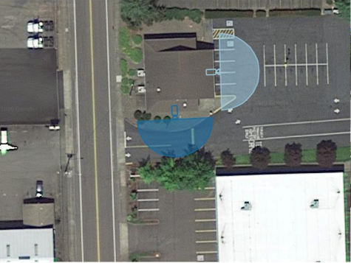
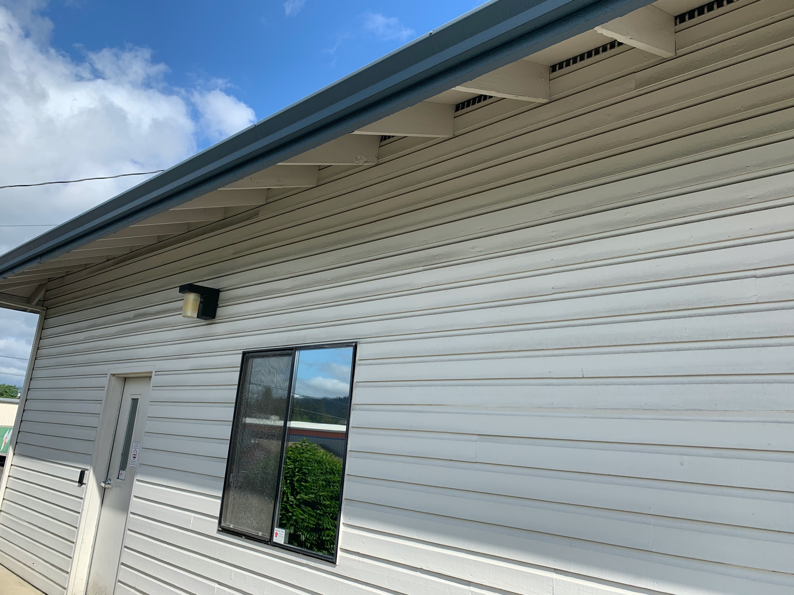
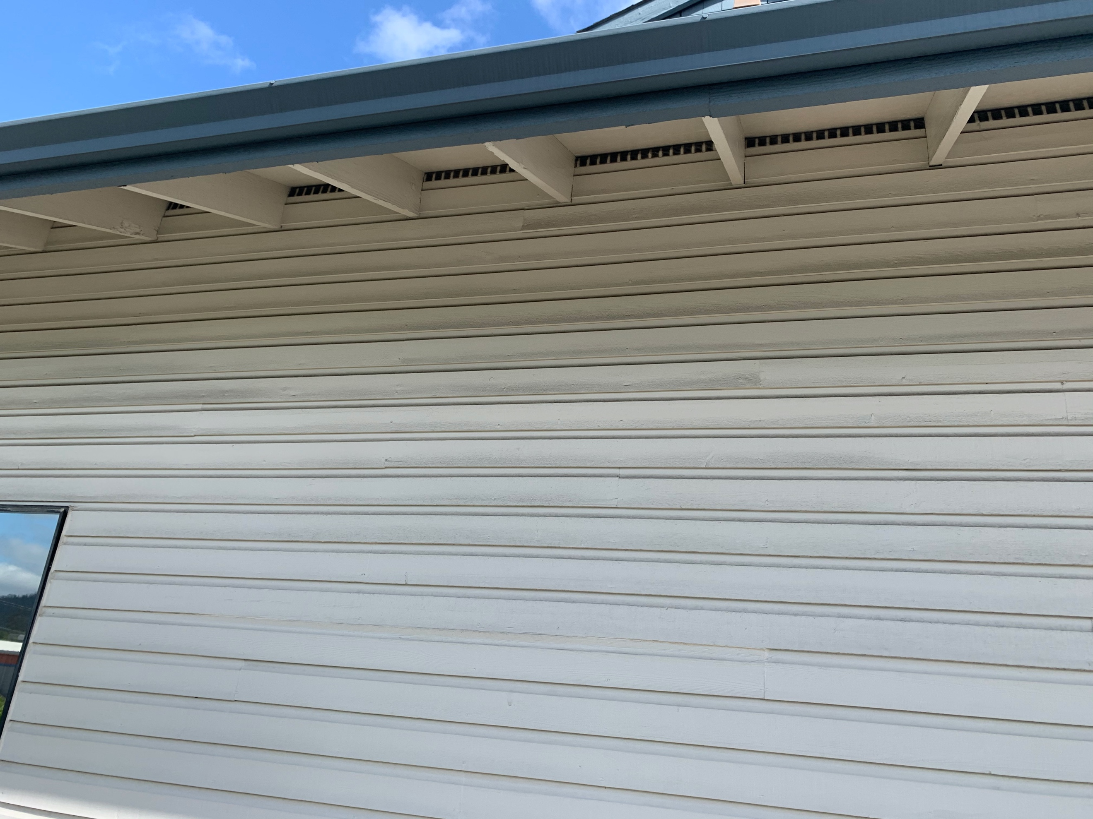

Camera 3:
Camera Model: PND-9080R
Required Accessories:
QTY 1: 32” Samsung Monitor – Model UN32N5300AFXZA
QTY 1: Peerless Ceiling Bracket – Model PLCM-UNL-CP
QTY 1: 10’ HDMI Cable
QTY 1: SPD-150 (Decoder)
QTY 1: Electrical Outlet
Mounting Location: The camera needs to be mounted to a roughly in line with the interior doorjamb (6’ from eastern wall) at a distance equal to the existing welcome sign. The TV and subsequent Decoder need to be installed at the location currently occupied by the welcome sign. The welcome sign should be moved so it in between the new camera and the TV. The Decoder should be attached to the ceiling bracket above the tile, so it is out of view.
The TV will require power scabbed off of an existing outlet.
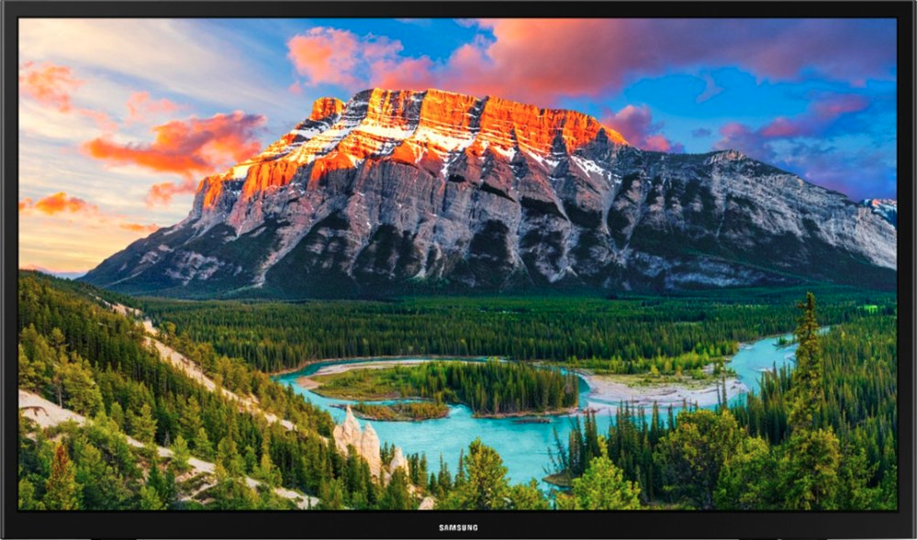
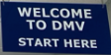
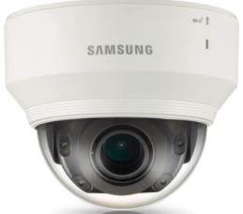
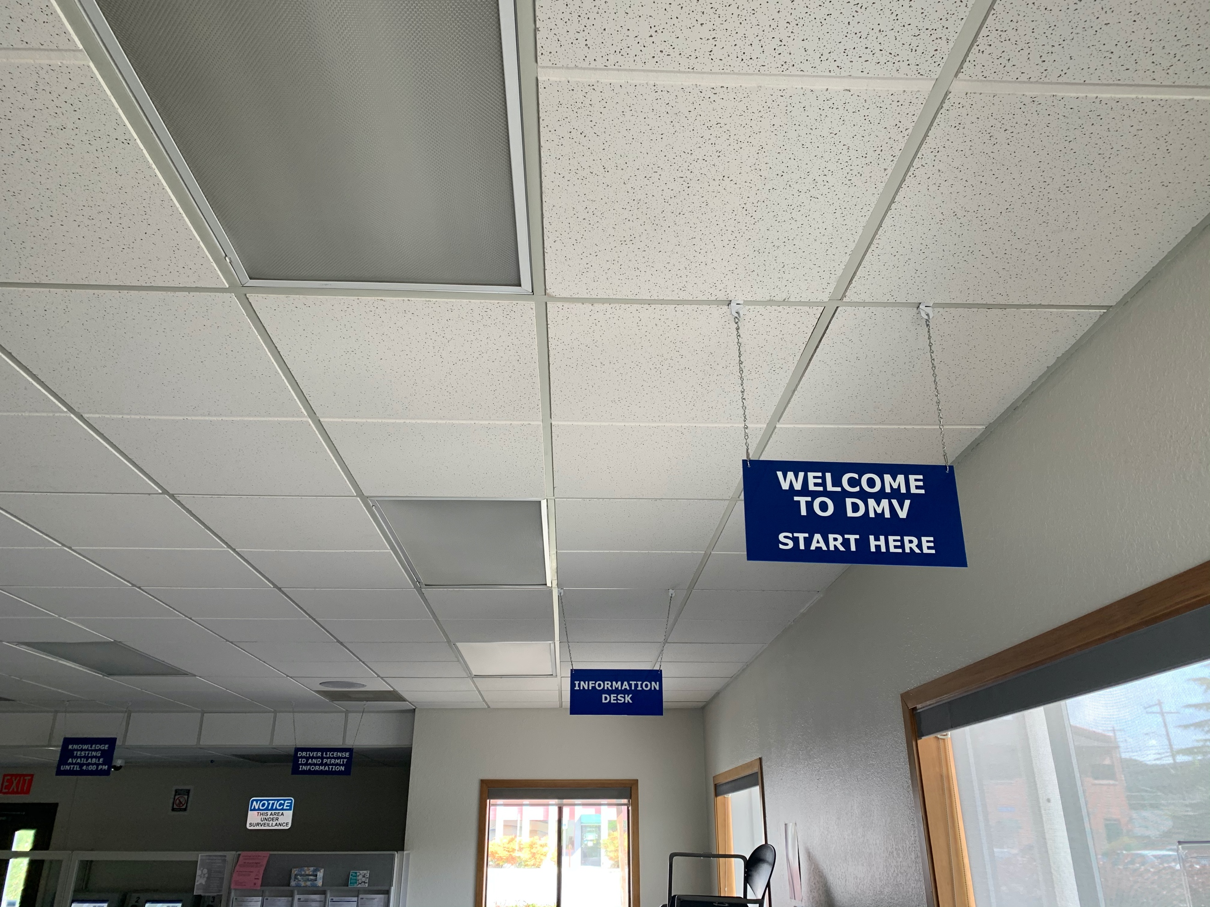
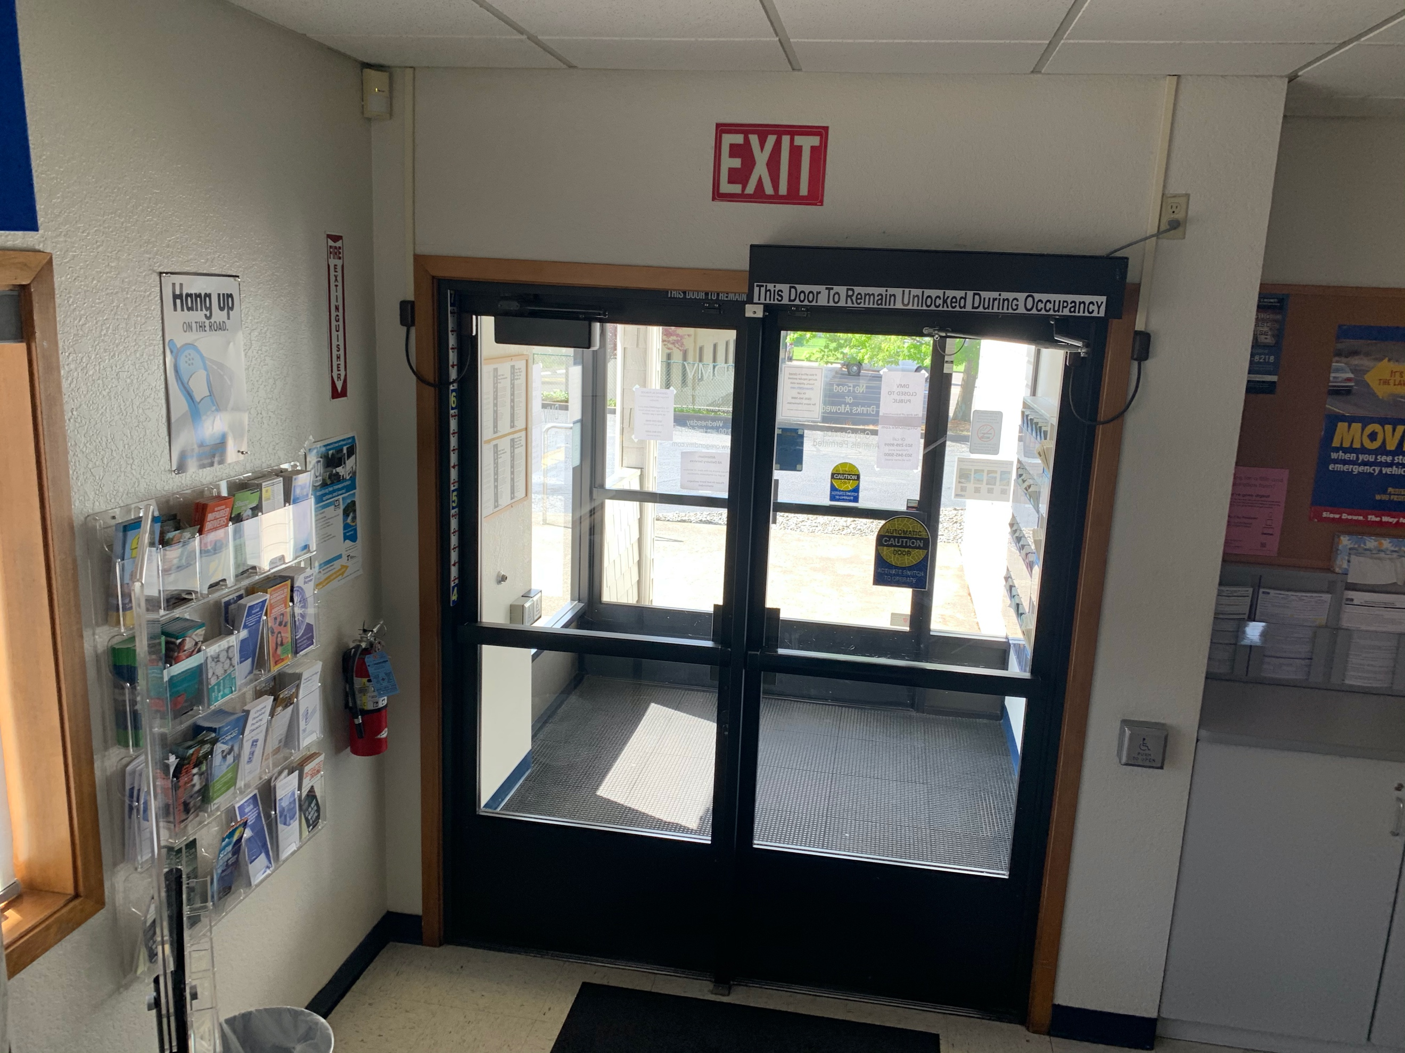
Camera view
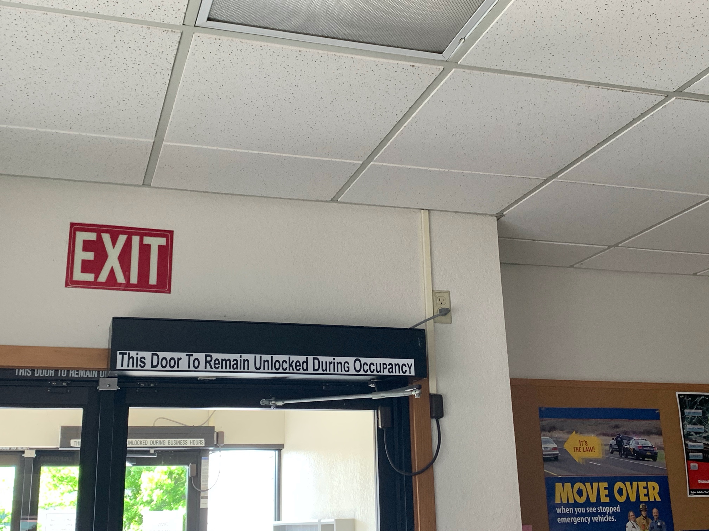
Suggested scab outlet

Camera 4:
Camera Model: PNM-9030V
Required Accessories:
None
Mounting Location: The camera should be installed, to the ceiling, in between the clock and the top row of license plates. The required view is of the customer side of the counter space.
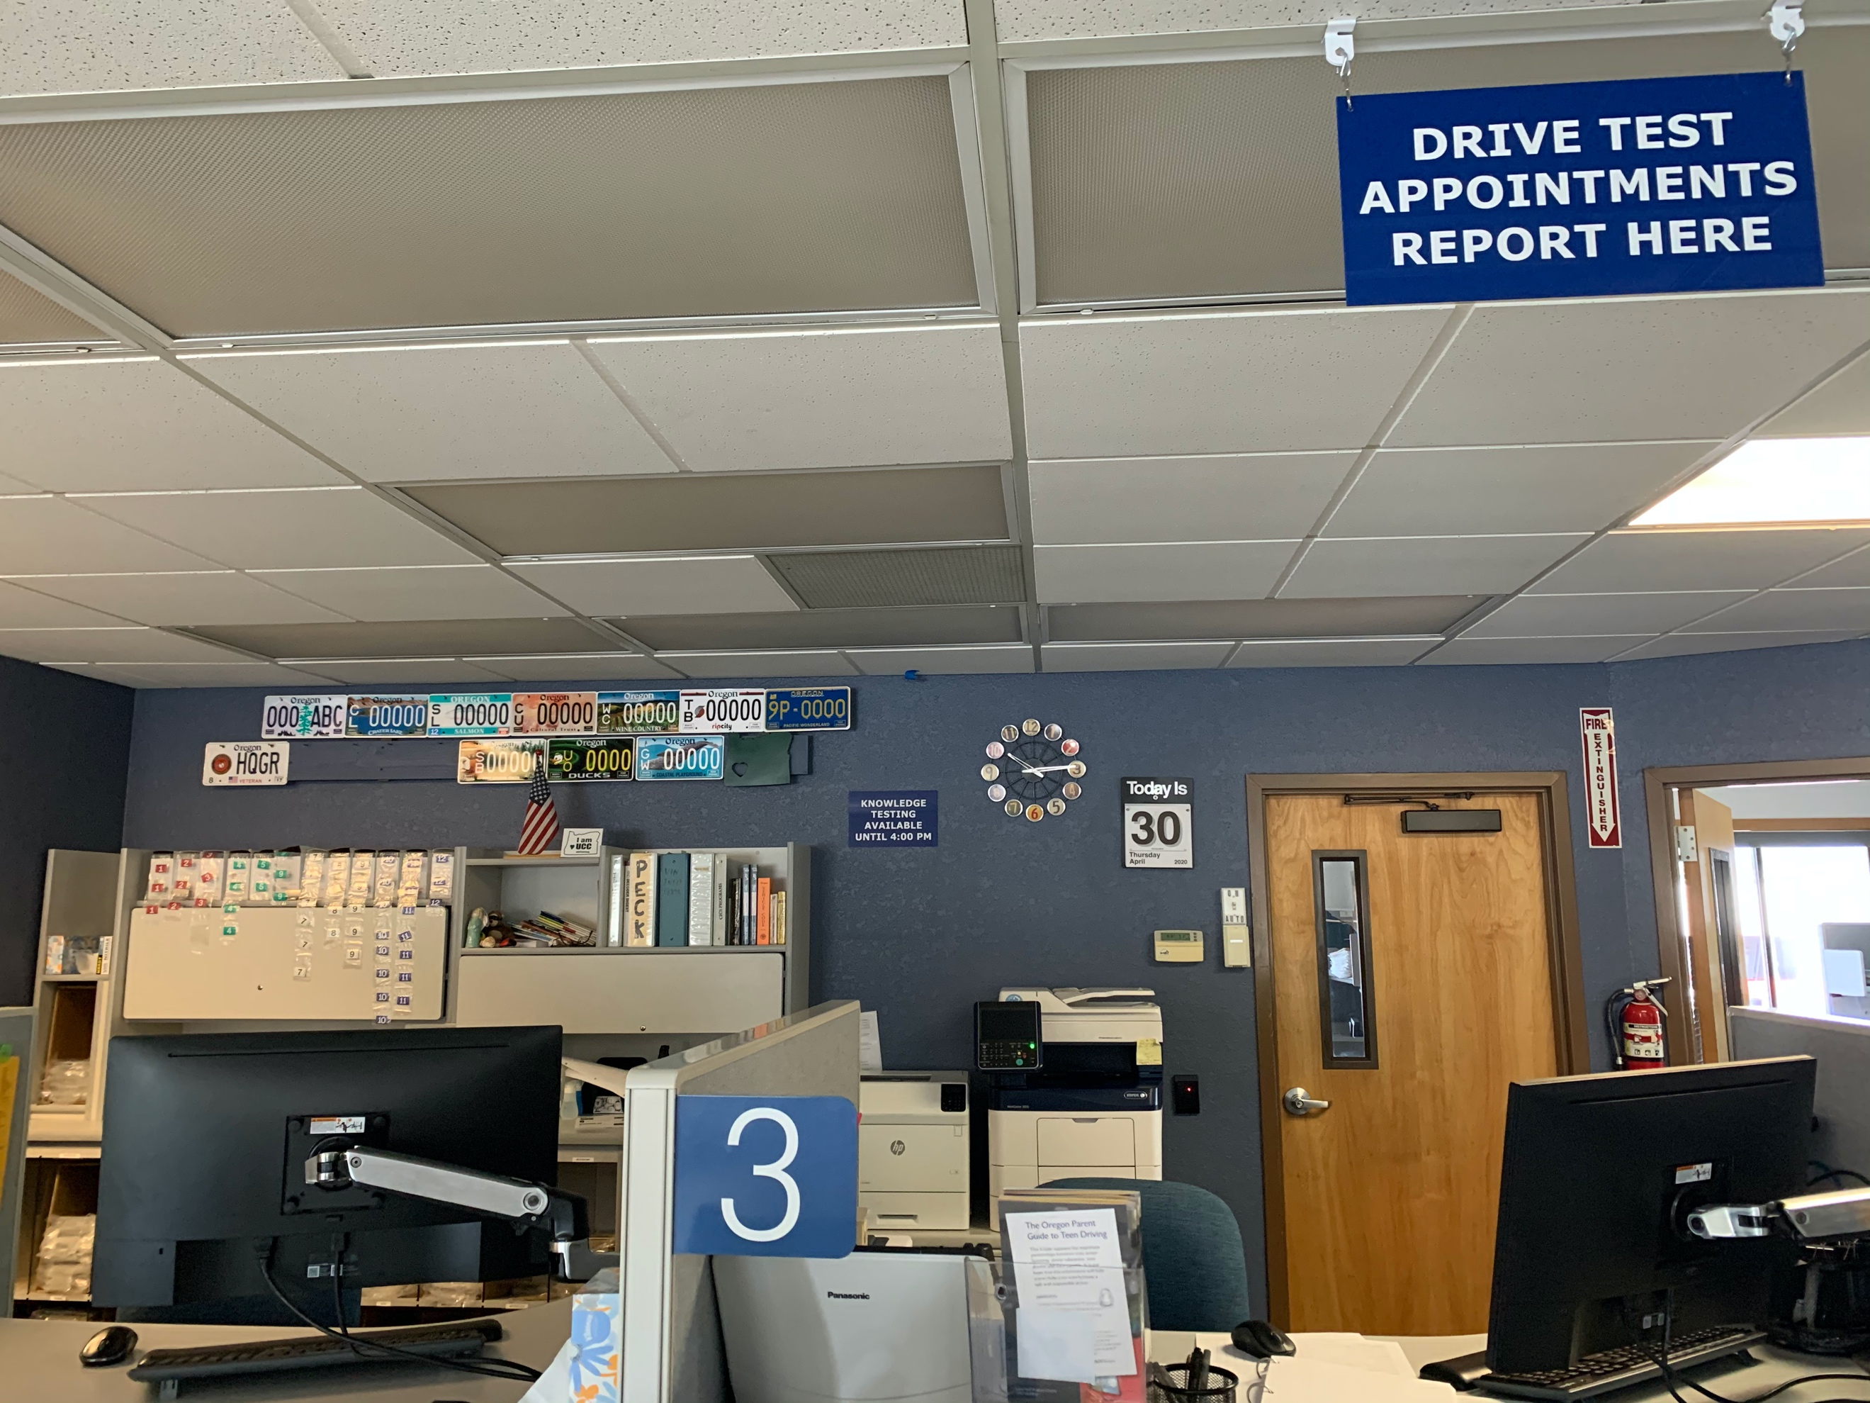
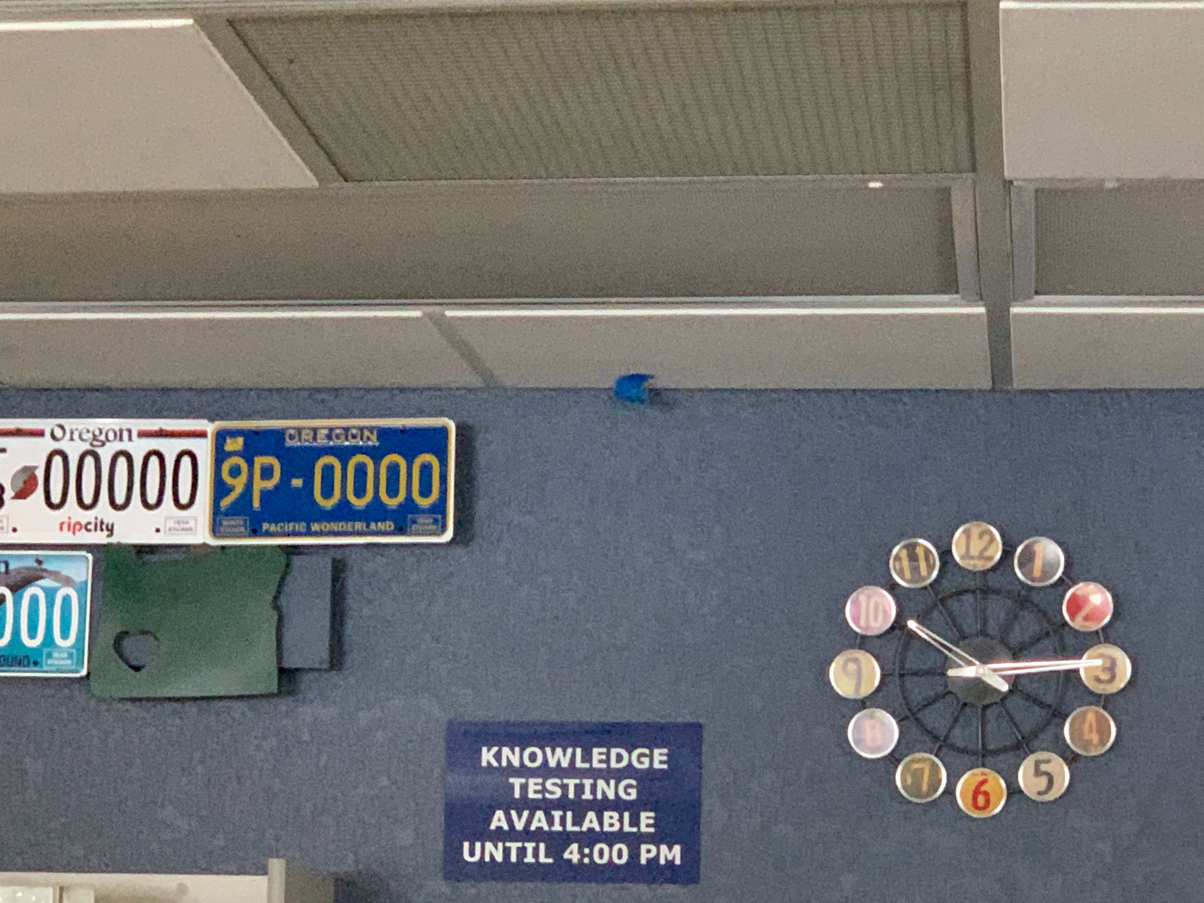

Camera 5:
Camera Model: PNF-9010R
Required Accessories:
QTY 1: 32” Samsung Monitor – Model UN32N5300AFXZA
QTY 1: Intel NUC PC – Model NUC8i7BEH
QTY 1: 6 HDMI Cable
QTY 1: Logitech Wireless Keyboard / Mouse Combo – Model MK235
Mounting Location: The camera should be installed to the center of the room (on the door side of the speaker). This is a 360° camera and the intention is to cover the comings and goings of this room and monitoring the safe located in the corner.
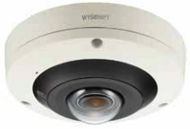
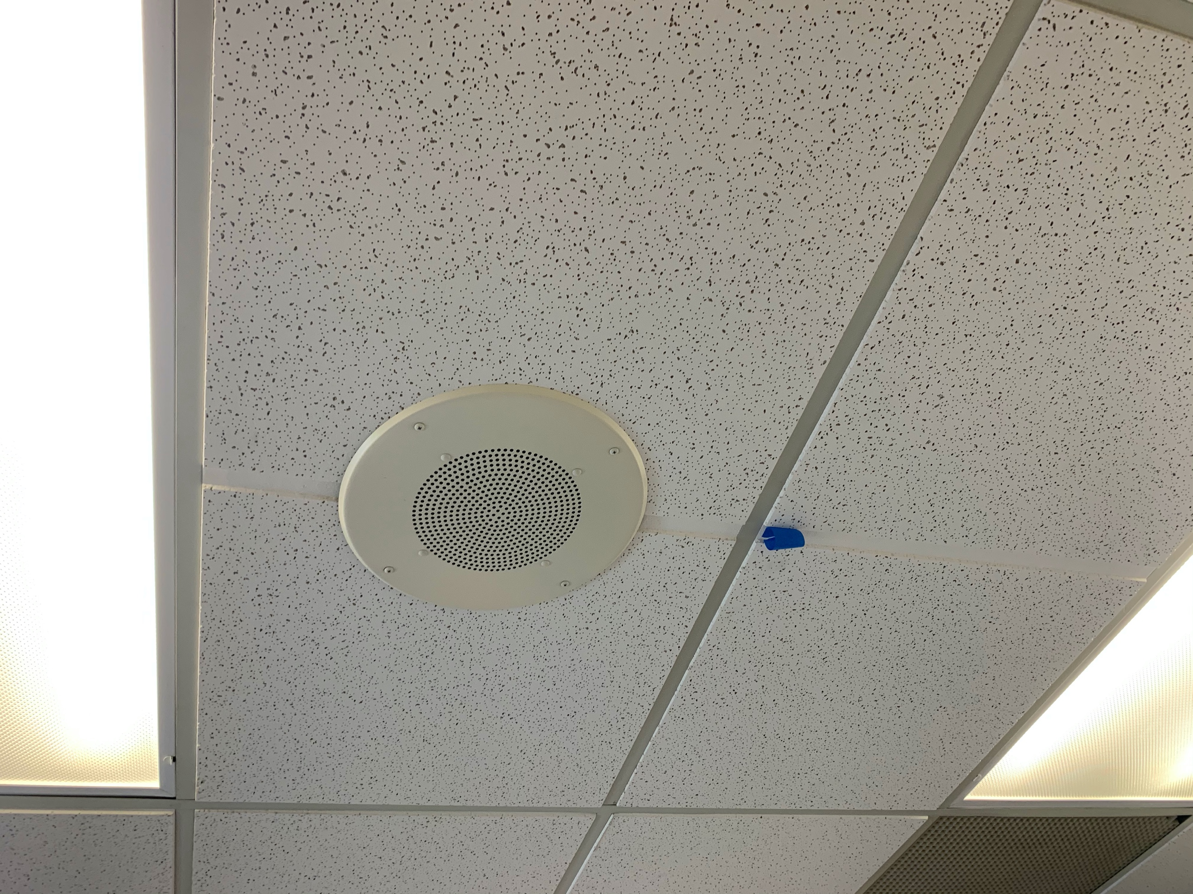
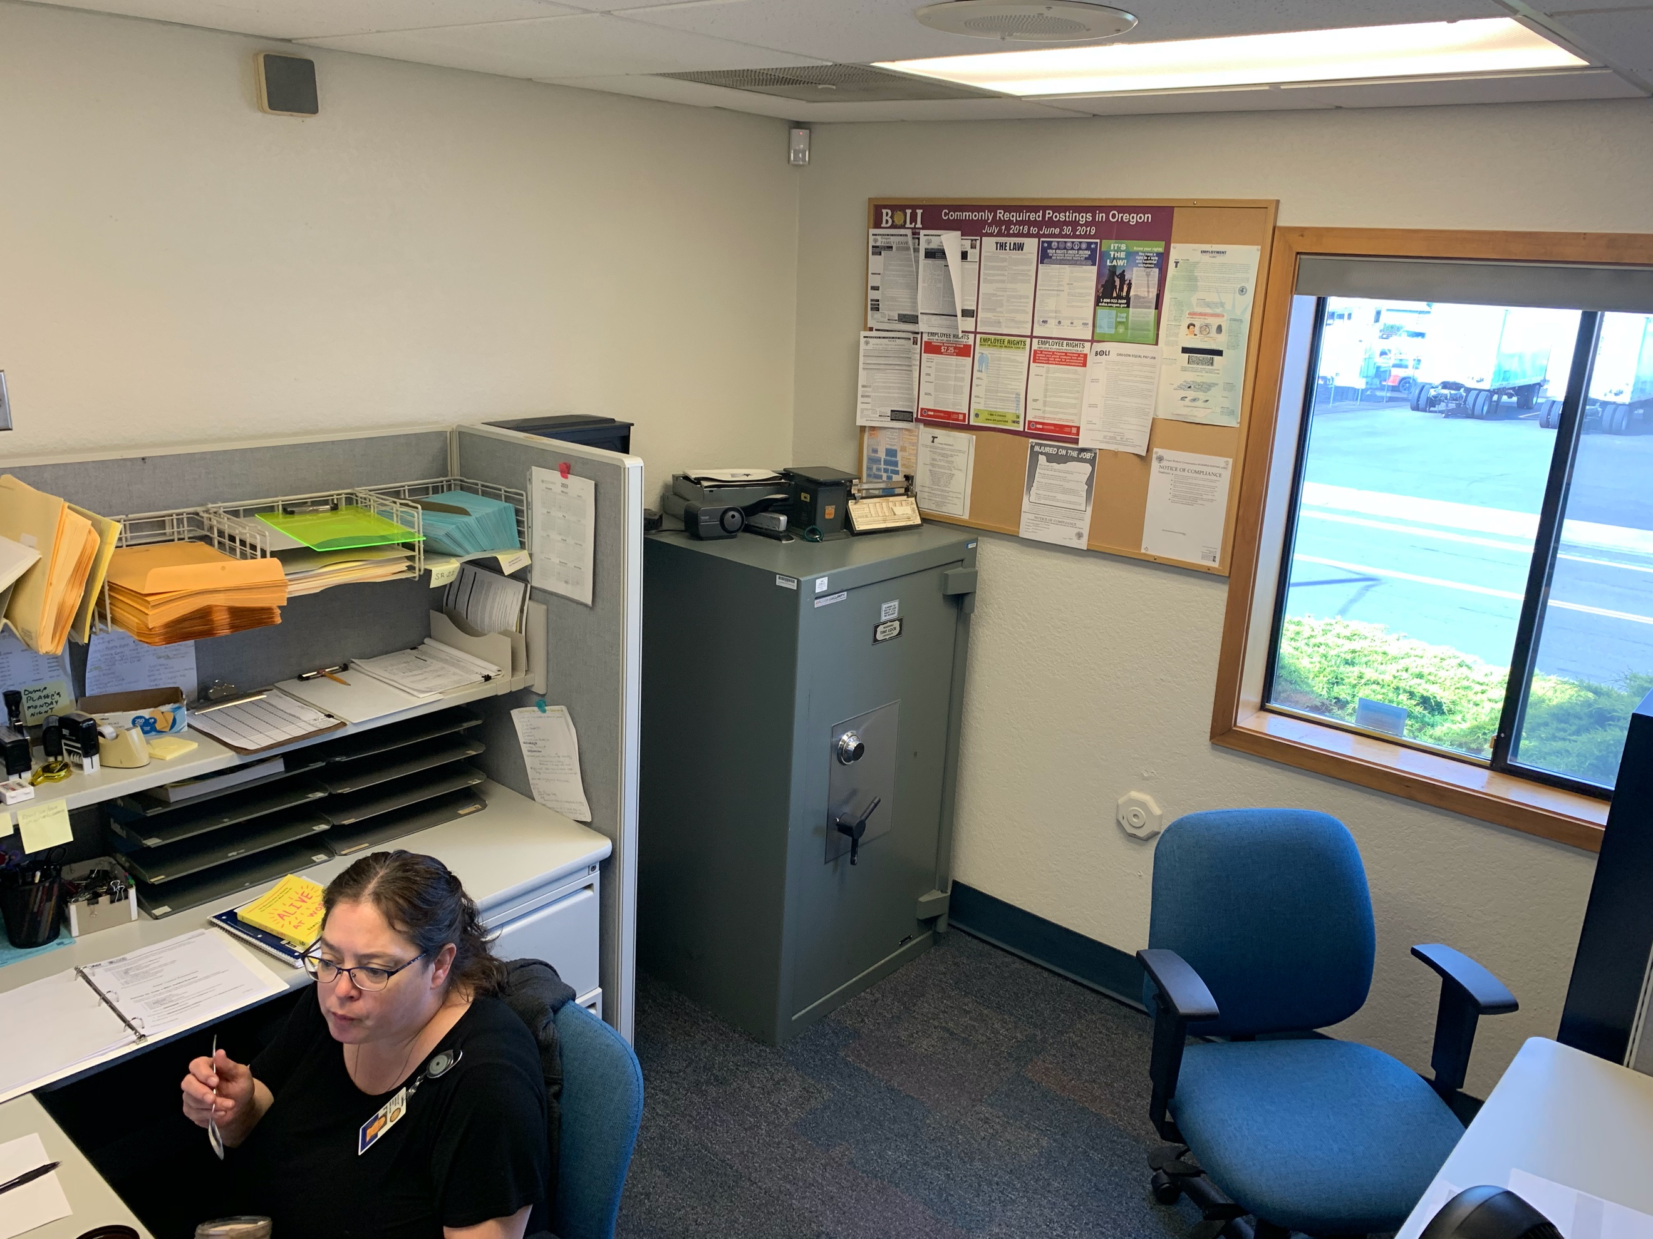
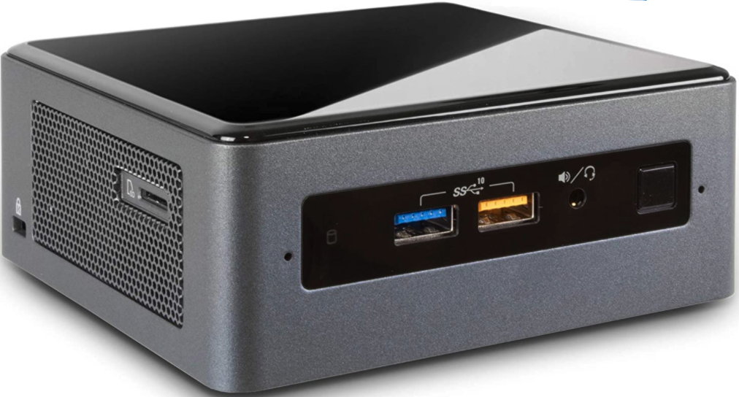
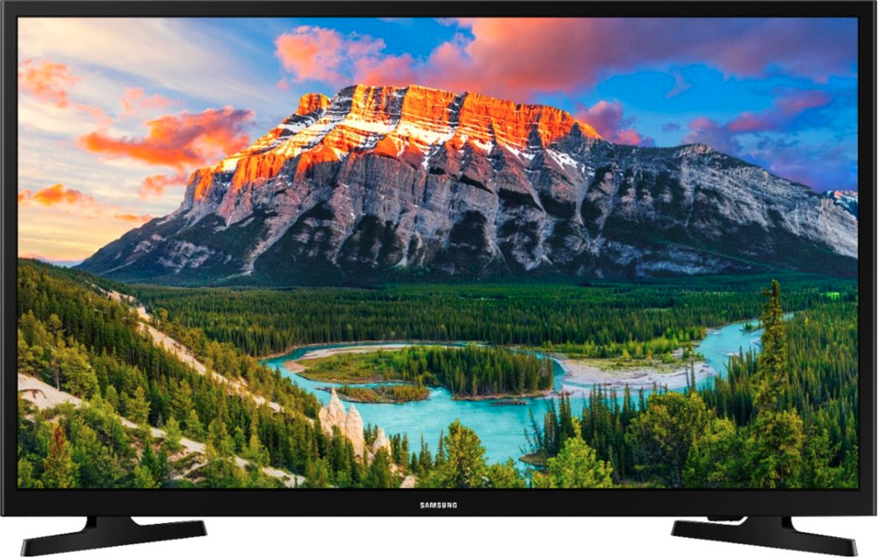
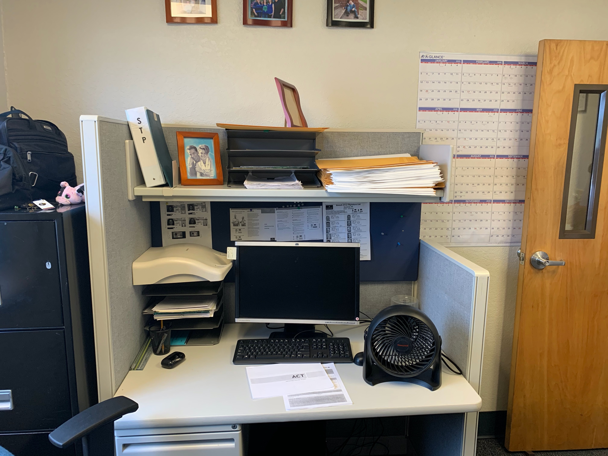

Camera 6:
Camera Model: PNF-9010R
Required Accessories:
None
Mounting Location: The camera should be installed roughly in between the two existing cameras. This project does NOT include demolition, so the existing cameras, and their subsequent cabling, need to stay in place. This is a 360° camera and the intention is to cover the testing area.
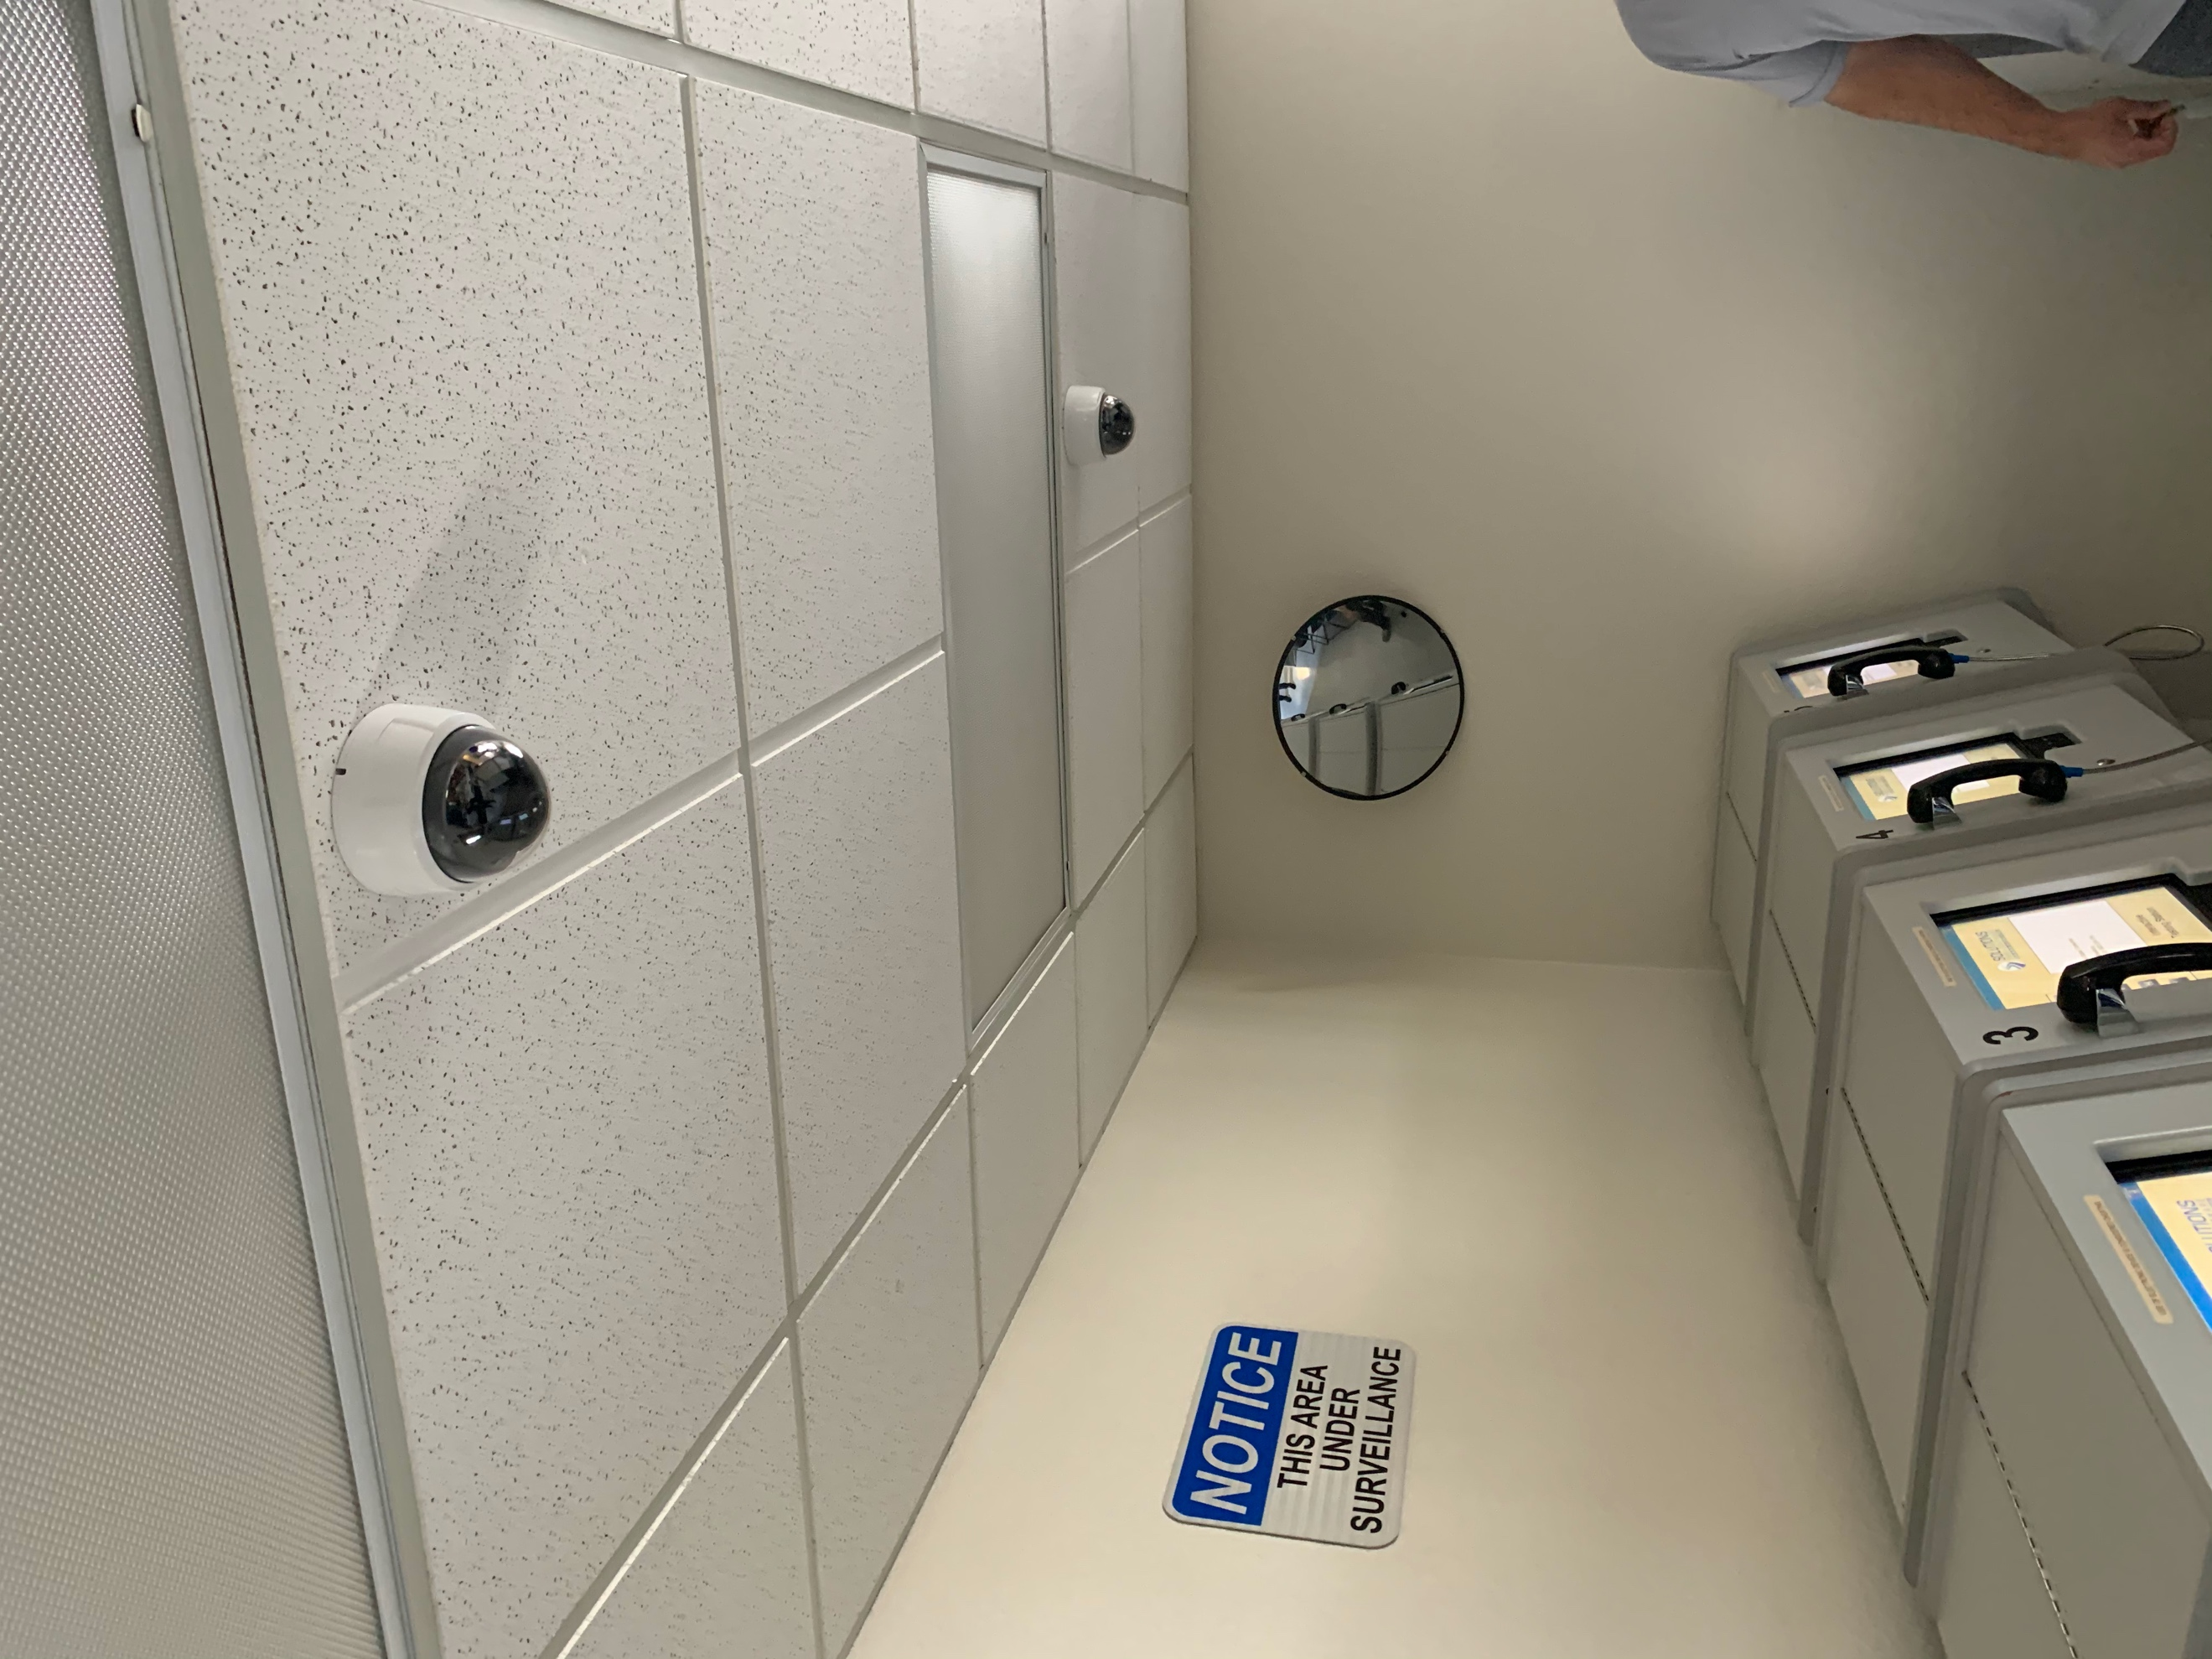

Server Room:
Camera Model: None
Required Accessories:
QTY 1: Vertiv UPS – Model GXT5-500LVRT2UXL
QTY 1: CAT6 Patch Panel
QTY 1: Electrical Outlet
Mounting Location: The UPS is to be installed at the bottom of the existing 2-post rack, and the patch panel should be installed far enough above it to allow room for their VMS server (to be installed by another contractor). This location will require an electrical outlet to be installed near the floor. This outlet can be scabbed off of one of the exiting outlets on the same wall.
