JR Merit
4505 NE 68th Dr
Vancouver, Washington 98661
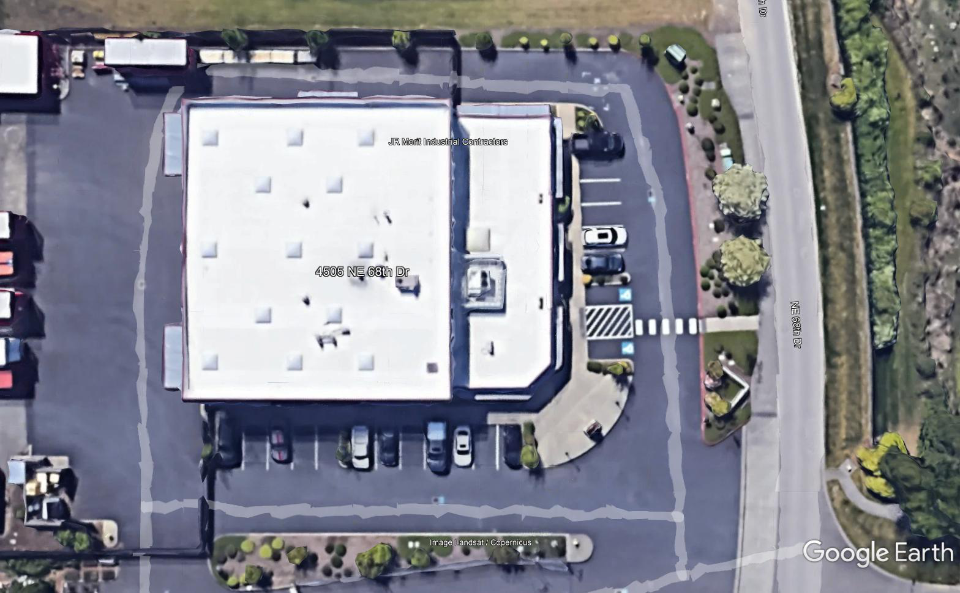

Omnidirectional Antenna
Low Profile Dome Antenna

